GOVERNMENT OF NCT OF DELHI
A & U TIBBIA COLLEGE & HOSPITAL
KAROL BAGH, NEW DELHI-110005

Name of Department: Tahaffuzi wa Samaji Tib
(Preventive & Social Medicine)

Details of Faculties
Name | Dr. Mohd Farooque | Dr. Ansari Shabnam
Date of Birth | 20.09.1982 | 10.09.1979
Photo | 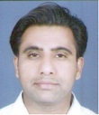 | 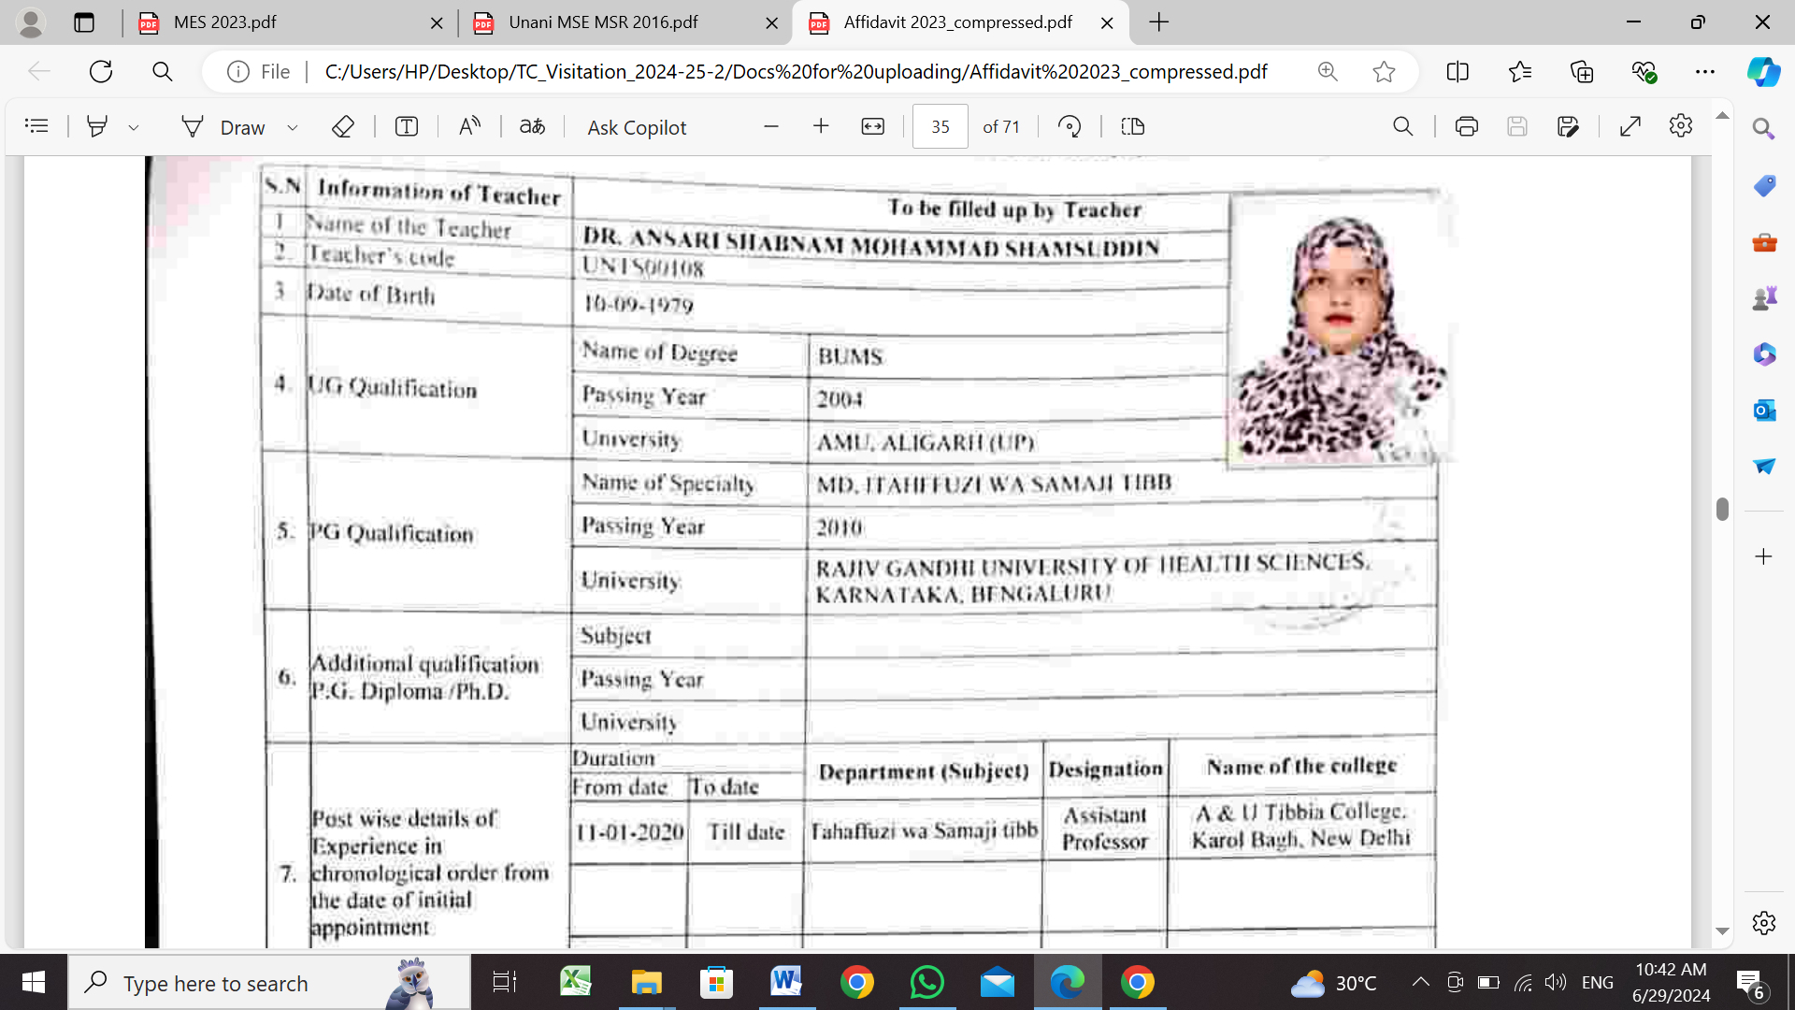
Teacher Code | UNTS00028 | UNTS00108
Reg. No. | 58260 | 9729
Edu. Qualification | BUMS, MD (Unani) | BUMS, MD (Unani)
Designation | Assistant Professor | Assistant Professor
Date of Joining | 02.08.2022 | 11.01.2020
Experience | 15 years | 4 years
Contact No. | 7000900629 | 9354925057
Email-id | drfarooquemd31@gmail.com | dr.shabs123@gmail.com
List of Research Publications | Research Papers: 09  Books: 02 | Research Papers: 00
OPD days and timings | Monday, Wednesday  (9:00 am to 1:00 pm) | Tuesday, Thursday, Saturday  (9:00 am to 1:00 pm)
PG Department present /absent | Absent
List of Students and Thesis Title | NIL
CME Seminars/ Conferences  Programmes etc. conducted by Department | NIL
Any awards or appreciations received, if any | NIL | NIL
Department Specialty in brief | This department mainly caters the Preventive and Promotive health care in Unani Medicine.

