Name of the Department- Shalyatantra Dept
Details of faculties
Details of faculties | Professor:1  Associate Professor : 01
Name | Dr. Dr Praveen kumar Chaudhary |  | Dr.Prashant L. Rasale | Dr.Santosh R. Naik
Date of Birth | 10/03/1970 |  | 18/06/1982 | 01/11/1985
Photo | 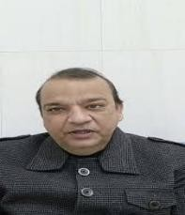 |  | 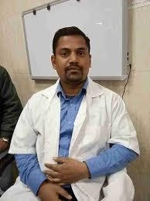 | 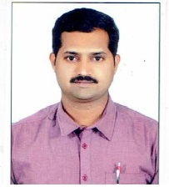
Teacher Code | AYUST01332 |  | AYUST01561 | AYST01329
Registration No. | DBCP/A/4075 |  | DBCP/A/9164 | 26030
Edu Qualification | MS(Ayu) |  | MS,PHD (SHALYA) | BAMSMS
Designation | Professor |  | Associate Professor | Asistant Professor
Date of Joining | 29/03/2001 |  | 11-4-2016 | 19/11/2024
Experience | 25 yrs |  | 15yrs | 11yrs
Contact No | 9968686823 |  | 9354925048 | 9148227525
Email ID | Praveensurgeon9@gmail.com |  | prashantrasale.22delhi.gov.in | ayurveda0111@gmail.com
List of Research Publications | 15 |  | 16 | 5
OPD Days and Timing | Tuesday, Friday 09:00-1:00 |  | Monday, Thursday 09.00-  1.00 | Wednesday, Saturday 09.00- 1.00
Any awards or  appreciations received, if  any | 03 |  | 2 | -
PG Department Present/Absent |  | Absent  National seminar on uttarbasti  Shalya Tantra is one of the eight departments in Ayurveda. It deals with surgical disorder and para surgical procedure like ksara karma, agni karma and jalauka karma (Leech therapy). It also deals with fracture and accidental injuries.  - The Dept run OPD on Daily basis with basic facilities to diagnose and treat surgical disorders.  - The Dept has O.T where general surgery performed daily.  - The Dept has para surgical unit where ksara karma, agni karma and jalauka karma (Leech therapy).  - Ksara karma (ksara sutra) is specially used for treating piles, fistula,fissure and pilonidal sinus.  - Agnikarma is used for treating corn, different type of pain.  - Leech therapy is used to treat non healing ulcer, burger's disease, cellulitis, skin disorders.  - General surgery  - Anorectal disorders  - Wound clinic  Urinary disorders
CME Seminars/Conferences etc. Programmes conducted by
Department
Department Speciality in brief

