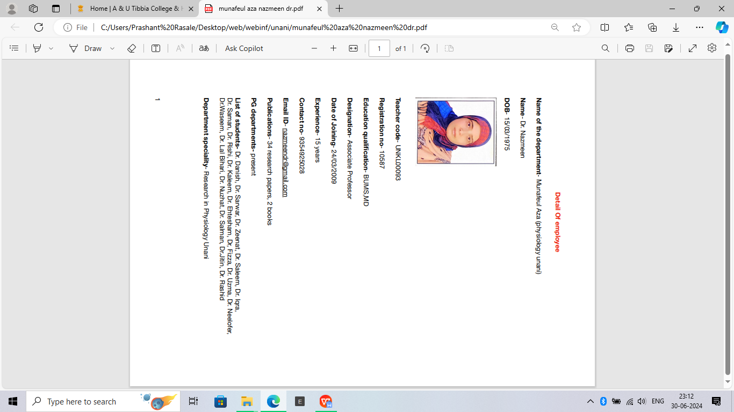

|  |  |
| --- | --- |
| Name of Department | Department of Manafeul Aza |
| Name | Dr **DANISH K CHISHTI** |
| Date of Birth | 05/05/1982 |
| Photo | C:\Users\USER\Downloads\Danish K Chishti.jpg |
| Teacher Code | UNMF00014 |
| Reg. No | DBCP/U/9158 |
| Edu. Qualification | BUMS,MD |
| Designation | Assistant Professor |
| Date of Joining | 06/02/2024 |
| Experience | 5 years |
| Contact No. | 9716562594 |
| Email Id | danishchishti2000@gmail.com |
| OPD Days and Timings |  |
| PG Department Present/Absent | Present |
| List of students and Thesis Title |  |
| CME Seminars/Conferences etc Programme conducted by Department |  |
| Any Awards or appreciations received,if any |  |
| Department specialty in Brief |  |
| List of Publications | **International Research Papers : 17**  **International Published Books: 07**  **Indian Published Book: 1** |
| **International Research Papers : 17**   1. Published research paper entitled as “Clinical Impacts of Cupping Therapy in Psoriasis” in Advances in Applied and Pharmaceutical Sciences Journal   (May 2018).   1. Published research paper entitled as “Hypertention and its management through Alternative Regimes of Unani Medicine.” In Research in Pharmacy and Health Sciences. (January 2017) e-ISSN : 2455-5258 2. Published research paper entitled as “Tabasheer (Bambosa Arudinacea) : a review in journal of the international society for the history of Islamic medicine. (April 2013) ISSN (1303-667x) 3. Published research paper entitled as “Incredible therapeutic benefits of Glycirrhaza Glabra” in pro journals.(July 2013). PRINT ISSN No. 2250 - 1991 4. Published research paper entitled as “Granules formation of Majoon Arad Khurma prepared with Stevia Rebaudiana as sweetening agent and its standardization in global jounal of medical research (USA).(Oct 2013)   Print ISSN : 0975-5888   1. Published research paper entitled as ”Clinical efficacy of Tukhme Karfas in the Management of Spasmodic Dysmenorrhoea” in FS Publications.(Nov 2013) 2. Published research paper entitled as “Concept of Contraception in Unani Medicine” in International Journal of Pharmacy. (Jan 2012).   PRINT ISSN No. 2250 - 1991   1. Published research paper entitled as “To evaluate the clinical efficacy of tila e hadaf in the management of erectile dysfunction” in global journal of medical research (USA) (Nov 2012). Print ISSN:0975-5888 2. Published research paper entitled as “An Antibacterial Activity of Raphanus Sativus linn seed extract” in global journal of medical research.(USA)(Dec 2012) Print ISSN:0975-5888 3. Published research paper entitled as “The Incredible Health Benefits of Saffron” in Indoglobal Research Library.(April 2011). 4. Published research paper entitled as “Incredible Medicinal use of Black Pepper: A view” In PARIPEX : Indian Journals of Research Volume 9 Issue 7,july 2020. 5. Published research paper entitled as “Glyciraahiza Glabra(Liquorice):Astaunding Medical benefits” in PARIPEX : Indian Journals of Research Volume 9 Issue 7,july 2020. PRINT ISSN No. 2250 - 1991 6. Published research paper entitled as “A socio Demographic study of schedule caste in certain areas of Delhi under Schedule Caste sub Plan(SCSP) Mobile Healthcare Programme” in PARIPEX : Indian Journals of Research Volume 9 Issue 11,Nov 2020. PRINT ISSN No. 2250 - 1991 7. Published research paper entitled as ” THERAPEUTIC POTENTIAL HEALTH BENEFITS OF AJWAIN (TRACYSPERMUM AMMI L.) in PARIPEX : Indian Journals of Research Volume 10, Issue 12, Dec 2021 PRINT ISSN No. 2250 – 1991 8. Published research paper entitled as “HEALTH STATUS OF CERTAIN AREAS OF NEW DELHI UNDER SCSP & TSP PROGRAMME” in INTERNATIONAL JOURNAL OF SCIENTIFIC RESEARCH Volume 11, Issue 08, Aug 2022 PRINT ISSN No. 2277 - 8179 9. Published research paper entitled as “Zeeq Un Nafas (Asthma) and their Understanding in the Past: Unani Concept” in Global Journal of Science Frontier Research: A Physics and Space Science Volume 22, Issue 5, Oct 2022 Print ISSN: 0975-5896 10. Published research paper entitled as “Integrative approaches to managing dysmenorrhea: a comprehensive review of unani medicine” in PARIPEX - INDIAN JOURNAL OF RESEARCH Volume- 13,Issue - 03 March – 2024,   ISSN : 2250 – 1991  **International Published Books: 07**   1. International published book entitled “History of Arthritis Clinical features, Diagnosis and Management” [ISBN NO: 978-3-659-16630-3]   Publisher : Lambert Academic Publishing(Germany)   1. International published book entitled “Temperamental approach of medical disorders in unani prospective. [ISBN NO: 978-3-659-13848-5]   Publisher : Lambert Academic Publishing(Germany)   1. International published book entitled “To evaluate the efficacy of tila e hadaf in the management of ED”. [ISBN NO: 978-3-659-26077-3]   Publisher : Lambert Academic Publishing(Germany)   1. International published book entitled “ Common medical disorders of urogenital system” [ ISBN NO : 978-3-659-14452-3]   Publisher : Lambert Academic Publishing(Germany)   1. International published book entitled ““An Analytical study of Pulmonary Functions in Healthy Young Adults of Different Mizaj”[ISBN NO : 978-1505987584]   Publisher : Lambert Academic Publishing(Germany)   1. International published book entitled “[The Premier Advance: MCQ's for Post Graduation Unani Entrance Examination](https://www.sapnaonline.com/books/premier-advance-mcq-s-post-dr-izharul-1545150451-9781545150450?position=1&searchString=" \o "The Premier Advance: MCQ's for Post Graduation Unani Entrance Examination)”[ ISBN NO :9781545150450]   Publisher : Academic Independent Publishing Platform,South Carolina, North Charleston, USA   1. International published book entitled “The Premier Advance” MCQ for Post Graduation unani Entrance examination ISBN 13: 9781545150450   **Indian Published Book: 1**   1. Indian published book entitled “ The Pioneer” MCQ for Post Graduation. Publisher : Idara Kitab ul Shifa (New Delhi) | |

|  |  |
| --- | --- |
| Name of Department | Munafeul Aza |
| Detail of faculties |  |
| Name | Mohd Saleem |
| Date of Birth | 04-01-1991 |
| Photo |  |
| Teacher Code | UNMF00011 |
| Reg. No | 2102(U) |
| Edu. Qualification | 1. B.U.M.S. A& U Tibbia College, Delhi University, Delhi, 2010-17 2. MD, Munafeul Aza, A& U Tibbia College, Delhi University, Delhi, 2017-2020 |
| Designation | Assistant Professor |
| Date of Joining | 02-02-2024 |
| Experience | 1. Assistant Professor, Jamia Tibbiya Deoband, Uttar Pradesh, May 2022-October 2023 |
| Contact No. | 9711110137 |
| Email id | mdsaleemchouhan1@gmail.com |
| List of Research publications | 1. *“Study of sleep, wake pattern in healthy individuals with reference to different Mizaj”*, International Journal of Unani and Integrative Medicine, pp 14-17, 2020 |
| OPD days and timings | NA |
| PG Department present/absent | Present |
| List of Students/Thesis title | - |
| CME Seminars/ conferences etc conducted by Department | - |
| Any awards or appreciations received if any | - |
| Department speciality in brief | Blood, Cardiovascular System |