**Name Of Department   : Jarahat**

Details of Faculties  : Two professors

NAME  : DR ABDUL NASIR

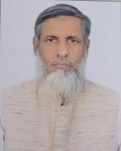

Date of BIRTH  : 01/12/1964

Teacher code  : UNMJ00183

Reg No  : BU/7050

Edu Qualification  : BUMS ، MD

DESIGNATION :  Professor

Date of joining   : 23/10/1998

Experience  : 27 years

Contact No  : 9013291253 / 9354925039

EMAIL ID: a۔nasir۔1119@gmail

List of publications  : Atleast 150 articles and Research papers

OPD Days and timings : Monday ، Wednesday and Friday : 9 am to 1pm

PG DEPARTMENT  ؛ Absent

Listening students and Thesis title : Nil

CME / Seminar/ Conferebce etc conducted   : Nil

Any awards or Appreciations  : 8 awards /Appreciations so far

Department speciality in brief  : Special treatment for non healing Ulcer

Special treatment for  Surgical disorders through Unani Medicine

Special treatment for Anorectal Diseases

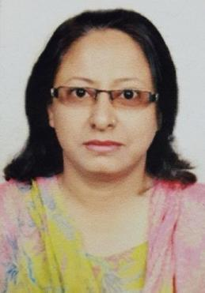

Dr Darakhshan khanam

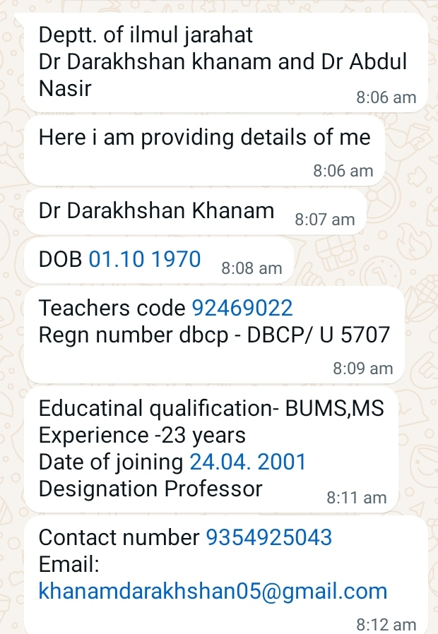

**NAME OF THE DEPARTMENT**

Department of Jarahat (Arabic equivalent of Surgery)

**INTRODUCTION TO THE DEPARTMENT**

A & U Tibbia College, Karol Bagh, New Delhi, is one of the best and leading academic institution of Unani Medicine in India, which has an excellent record of providing quality unani medical education for the past 100 years. The Department of Jarahat is an integral part of it and occupies an important place in the curriculum of Unani Medicine. It was established as an under graduate department from the very beginning and starting day of this institution, i.e. 1916. Jarahat is one of the prestigious modes of treatment and has a deep route in Unani Medicine. It is an effective way through which we can successfully treat and manage certain disorders along with other methods of treatment as a last resort.

The purpose of establishment of department of Jarahat is: -

1. To produce excellent and efficient teachers/researchers in the field of Jarahat.
2. To fulfill the minimum standard for Tibbia College laid down by CCIM.
3. To rejuvenate the department of Jarahat according to need of modern scientific world.
4. To increase the scope of training particularly in Jarahat at under graduate and post graduate level.

The department is doing all best efforts for development of Jarahat in clinical training research studies, specialization of the subject and service to the humanity. We are trying to produce best trained teacher/researchers to overcome the crisis being faced by Unani Colleges in the field of Jarahat. For this purpose we are not only using unani drugs in surgical patients but also practicing minor surgeries in certain disorders.

**SPECIALITIES OF DEPARTMENT OF JARAHAT**

1. The department of Jarahat has the distinction of conducting successful research in the treatment of different types of chronic non healing wounds and ulcers.
2. Special treatment for soft tissues injuries.
3. Application of Leeches, Cupping, Venesection, Fomentation, Massage, Exercise, Sitz bath and Cauterization in various surgical diseases.
4. Various classical unani ointments and liniments for local application are being used as a dressing material for healing purposes of different types of wounds, ulcers, burn wound and in other injuries instead of using conventional ointment such as betadine, mercurochrome and others.
5. Minor surgical procedures such as debridement of wounds, drainage of abscesses, excision of benign tumours and cyst, keloid, corn, ganglion and for ano-rectal diseases through modern surgical techniques.

**CONSULTANT DETAILS**

At present,there two consultants in the department. They possess good and unblemished academic record and are expert and efficient in their subjects and have a long standing teaching and clinical experiences.

1. **DR. ABDUL NASIR**: - Associate Professor. He is graduate (B.U.M.S.) from University of Delhi in 1989 and P.G. (M.D.) from Jamia Hamdard in 1997.

OPD DAY**S: -** Monday, Wednesday, Friday

IPD DAYS : - Tuesday, Thursday, Saturday

1. **DR. DARAKHSHAN KHANAM**: - Associate Professor. She is graduate (B.U.M.S.) from Aligarh Muslim University in 1995 and P.G. (M.S.) from the same institution in 2000.

OPD DAYS: - Tuesday, Thursday, Saturday

IPD DAYS : - Monday, Wednesday, Friday

The daily number of patients in each day range between 70 – 100/ day & I.P.D. patients number range 12 -15 against 10 beds.

**RESEARCH ON GOING**

1. Clinical efficacy of Hijamat Bil Shrut (Wet Cupping) in the management of Frozen Shoulder and Low backache.
2. Role of Heal-up cream dressing in non-healing ulcer patients.
3. The effect Zimad-e-Muhallil in ganglionic swelling.
4. The effect of a unani formulation in the treatment of orchitis.
5. Evaluation of some unani drugs in the treatment of B.P.H. in its early stage.
6. The efficacy of Tukhm-e-Alsi in the treatment of injection abscess.
7. The use of leeches in thrombosed pile mass.
8. The effect of raw papaya in the treatment of diabetic ulcer.
9. The role of Para-surgical procedures in the management of soft tissue injuries.
10. Treatment of carpal tunnel syndrome with the help of Fasd (Venesecction).

**AVAILABLE INSTRUMENTS, EQUIPMENTS, CHARTS AND MODELS**

**INSTRUMENTS**

1. Artery Forceps
2. Allis Tissue Forceps
3. Babcocks Tissue Forceps
4. Bard Parker Knife
5. Curved Scissors
6. Cheatle Forcep
7. Dissecting Forceps with teeth
8. Dissecting Forceps
9. Different Types of suturing Needles
10. Fistula Probe
11. Gauze Cutting Scissor
12. Gabriel’s Syringe for Injection Treatment of Haemorrhoids
13. Kocher’s Artery Forceps
14. Kocher’s Haemostatic Forceps
15. Lane’s Tissue Forcep
16. Mosquito Forcep
17. Mayo Towel Clip
18. Needle Holding Forceps
19. Proctoscope
20. Pile Gun
21. Pile Forceps
22. Scalpel
23. Sponge Holding Forceps
24. Sinus Forceps
25. Towel Clip
26. Toothed Forceps
27. Venflow or Intracath

**CHARTS**

1. Aalat Zahrawi
2. Surgical Contribution of Zahrawi
3. Surgical Contribution of Al-Razi
4. Acute Abdomen
5. Showing the steps of Haemorrhoidectomy
6. Ryles tube/Nasogastric tube
7. Wound Healing
8. Rule of Nine
9. B.P.H.
10. Scopy, Trypsy & other Technique
11. Pleural Fluid Aspiration
12. Suturing Material
13. Surgical Knots
14. Skin Tumours
15. Skin Grafting
16. Blood Transfusion
17. Haemorrhoid Injection Therapy
18. Articular Diseases
19. Meatotomy
20. Dressing of Wound
21. Types of Syringe
22. Tubectomy
23. Types of Hernia
24. Fistula in Ano
25. Inflammation
26. Types of Fracture
27. Cholecystectomy

**MODELS**

1. Surgical Instruments used in Unani Medicine
2. Instruments used in Venesection
3. Diabetic Foot
4. Hydrocele
5. Suturing Material
6. Drainage Tube
7. Types of Catheter
8. Paracentasis
9. Flatus Tube
10. Stomach Tube
11. Blood Transfusion