Departmental Details

Department of Ilmul Advia
S.NO. | Details of Faculties
1 | Name | Dr. SAUDUZ ZAFAR ALI | Dr. SYED MOHD FAISAL IQBAL | Dr. MOHD AMIR | Dr. RASHMI ANAND
2 | Date of Birth | 01.02.1977 | 01.08.1976 | 01.04.1974 | 05.07.1978
3 | Photo | 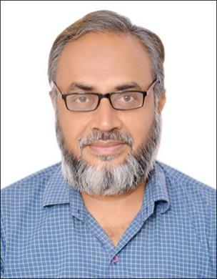 |  | 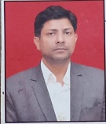 | 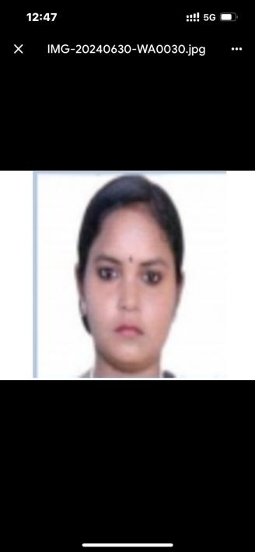
4 | Teacher Code | UNID00206 | UNID00039 | UNID00216 | NA
5 | Reg. No. | DBCP/U/7489 | 09622 | DBCP/U/ 7961 | NA
6 | Edu. Qualification | BUMS, MD | BUMS, MD | BUMS, MD | M.Sc, Ph.D
7 | Designation | Assist. Professor | Assist. Professor | Assist. Professor | Guest Faculty
8 | Date of Joining | 30.01.2009 | 08.11.2019 | 13.06.2013 | 27.09.2011
9 | Experience | 19 years | 14 Years | 10 years | 13 years
10 | Email - ID | Saud.ali7@gmail.com | smfaisaliqbalk16@gmail.com | dramiralig@gmail.com | rashanand@gmail.com
11 | List of Research Publication
12 | OPD Days and Timing |  |  | MWF in Unani Dispensary of XYZ Block, New Ranjit Nagar, Shadi kham Pr, Delhi-12 GNCT of Delhi  TTS in Unani Dispensary of Acharya Bhikshu Hospital, Moti Nagar, Delhi
13 | PG Department Present/absent | Absent
14 | List of Student and Thesis Title | NA
15 | CME Seminar/Conference etc. Programmes conducted by Department | NA
16 | Any awards or appreciation received, if any | NA
17 | Department Specialty in brief | Department of Ilmul Advia, being an integral part of this institute played a very important role since advent of this institution. The main object and motive of this department is to teach and train the students in such a manner where they could be able to understand the basic principles of Ilmul Advia, to identify the drugs and to learn their uses in various conditions and in various dosage forms. For these objects department has two herbal gardens and a museum for single drugs where drugs are preserved for practical demonstration to the students. Department has highly experienced and skilled faculty in the field of Ilmul Advia who are dedicated to impart the knowledge and skills to the students. All classical as well as modern techniques of teaching and training are employed for holistic and technical development of Unani understanding and knowledge among the students. Emphasis is laid upon developing interest among students to make them eager to explore the classical and reference books of Ilmul Advia to combat the new health challenges. Further, emphasis is also given to nourish them as a competent and best Unani Physician.

