HOSPITAL DATA

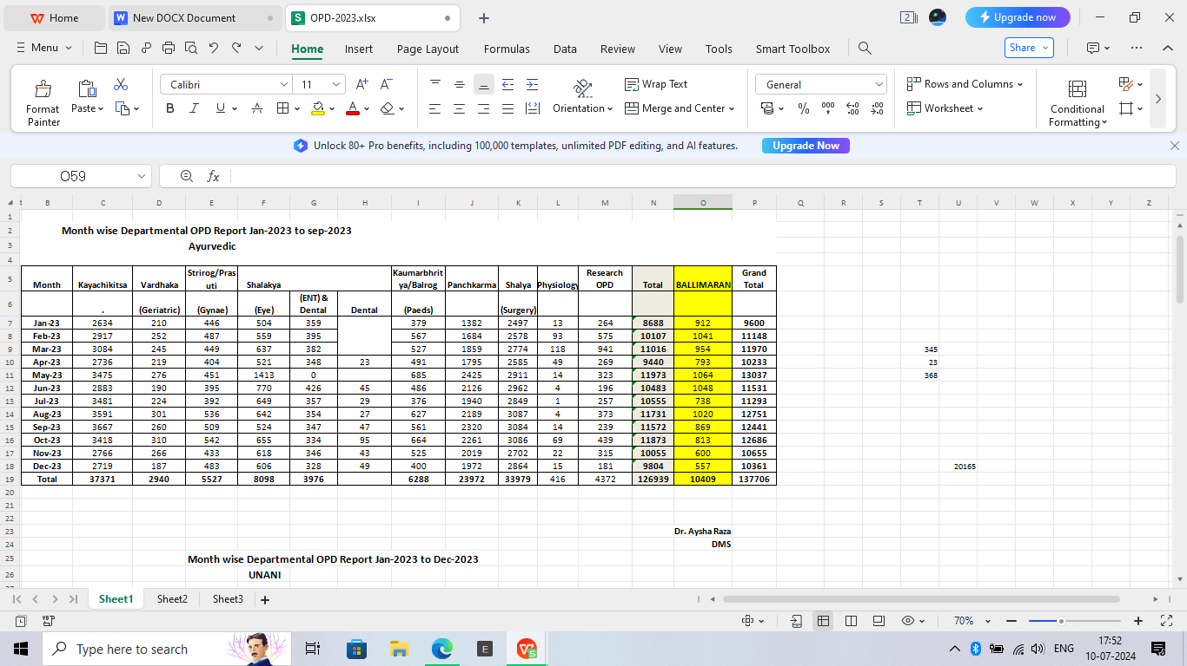

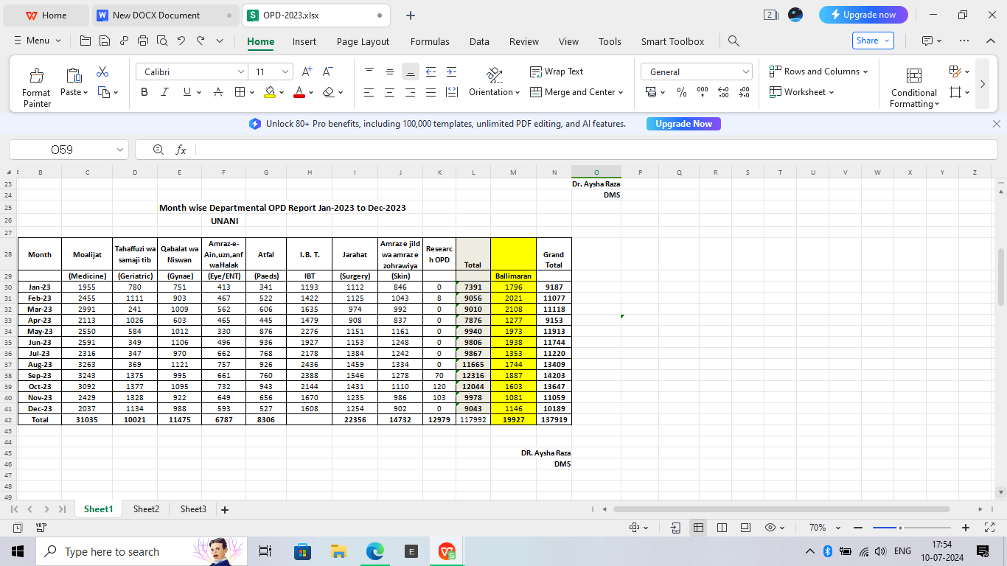

**Month wise Departmental OPD Report Jan-2023 to Dec-2023**

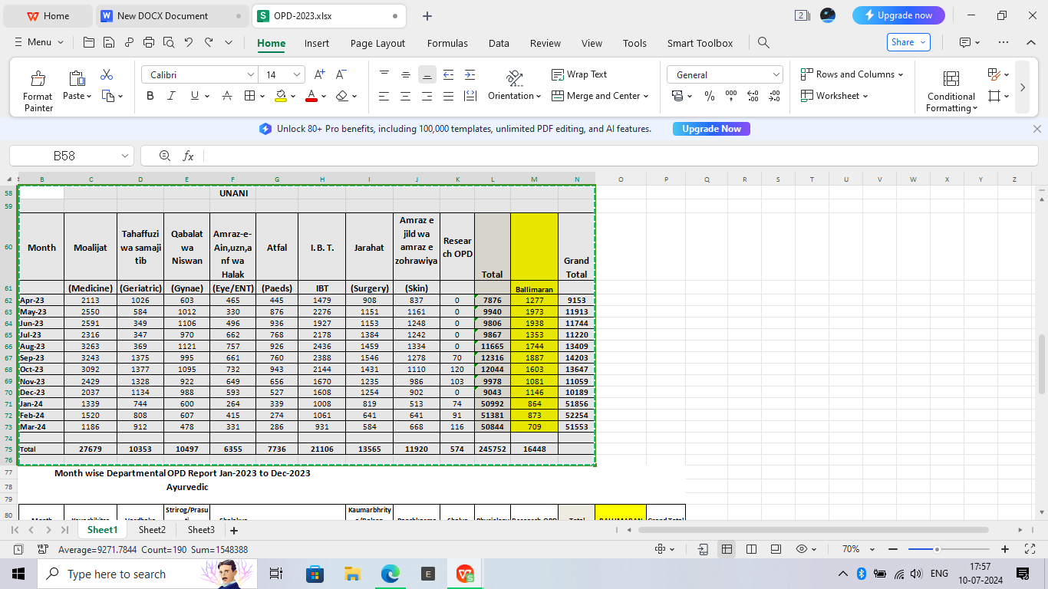

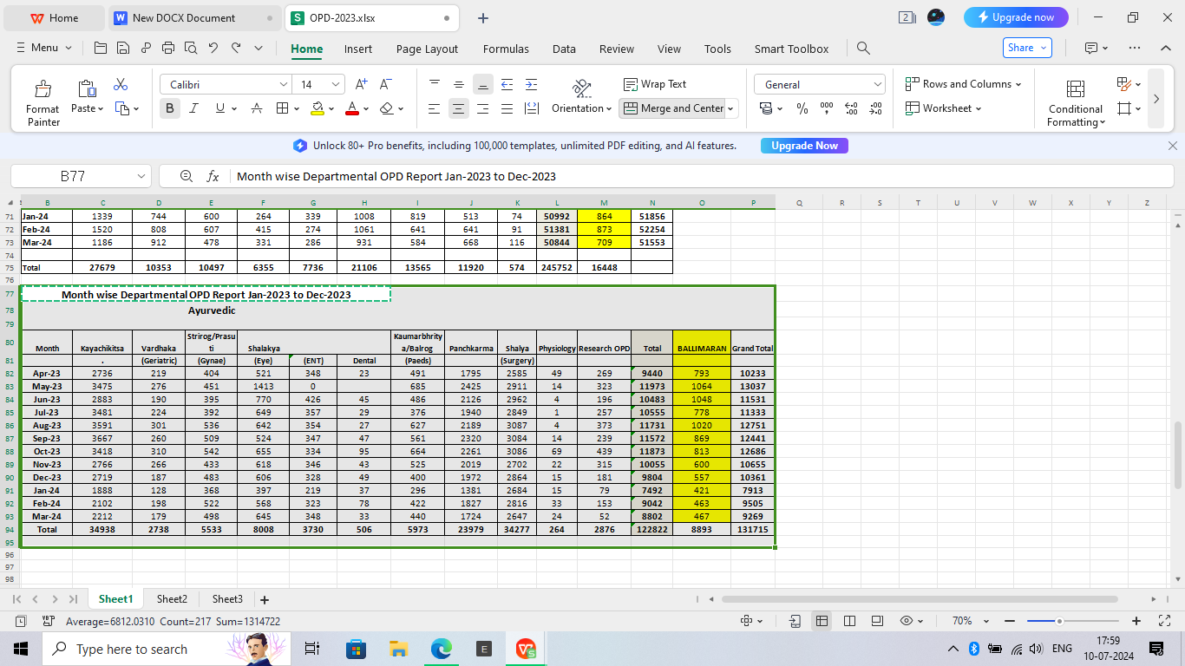

**MONTHWISE NEW AND OLD Patients**

|  |  |  |  |
| --- | --- | --- | --- |
|  | **Ayurvedic** |  |  |
|  |  |  |  |
| **MONTH** | **OLD** | **NEW** | **TOTAL** |
| **Jan-23** | 1833 | 6855 | 8688 |
| **Feb-23** | 4442 | 5665 | 10107 |
| **Mar-23** | 5046 | 5970 | 11016 |
| **Apr-23** | 2336 | 7104 | 9440 |
| **May-23** |  |  | 0 |
| **Jun-23** | 5009 | 5474 | 10483 |
| **Jul-23** | 5420 | 5135 | 10555 |
| **Aug-23** | 6515 | 5215 | 11730 |
| **Sep-23** | 6410 | 5162 | 11572 |
| **Oct-23** | 6089 | 5784 | 11873 |
| **Nov-23** | 5456 | 4599 | 10055 |
| **Dec-23** | 5077 | 4727 | 9804 |
| **Total** | 53633 | 61690 | 115323 |

|  |  |  |  |  |  |
| --- | --- | --- | --- | --- | --- |
|  | **Unani** |  |  |  |  |
|  |  |  |  |  |  |
| **MONTH** | **OLD** | **NEW** | **TOTAL** |  | **Grand Total** |
| **Jan-23** | 1970 | 5421 | 7391 |  | **16079** |
| **Feb-23** | 3786 | 5270 | 9056 |  | **19163** |
| **Mar-23** | 3900 | 5110 | 9010 |  | **20026** |
| **Apr-23** | 3488 | 4388 | 7876 |  | **17316** |
| **May-23** |  |  |  |  | 0 |
| **Jun-23** | 3954 | 5852 | 9806 |  | **20289** |
| **Jul-23** | 4527 | 5340 | 9867 |  | **20422** |
| **Aug-23** | 5464 | 6291 | 11755 |  | **23486** |
| **Sep-23** | 5917 | 6399 | 12316 |  | **23888** |
| **Oct-23** | 5770 | 6274 | 12044 |  | **23917** |
| **Nov-23** | 4661 | 5317 | 9978 |  | **20033** |
| **Dec-23** | 3952 | 5091 | 9043 |  | **18847** |
| **Total** | 47389 | 60753 | 108142 |  | **223466** |

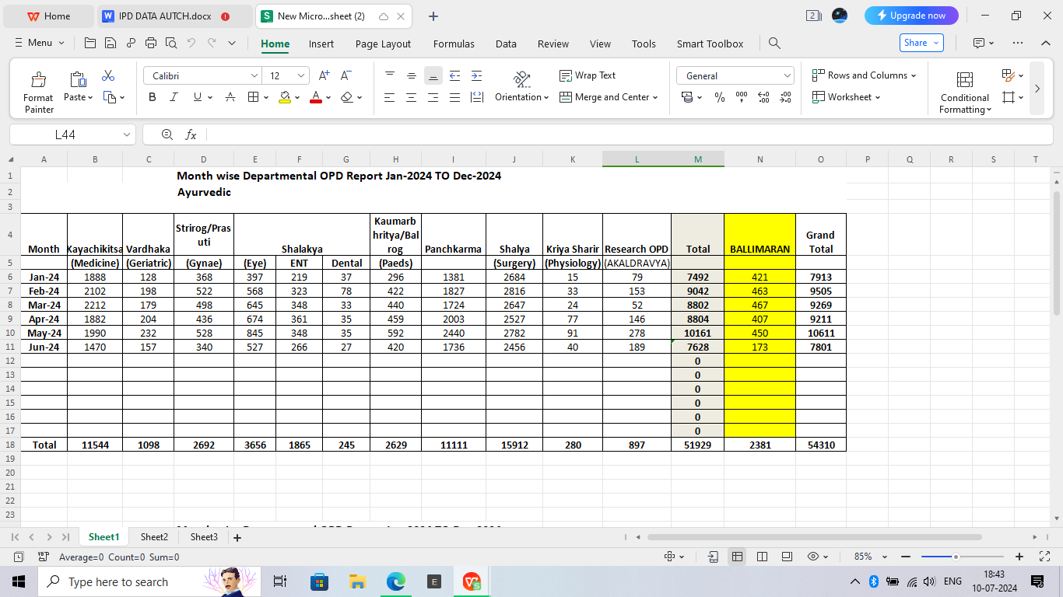

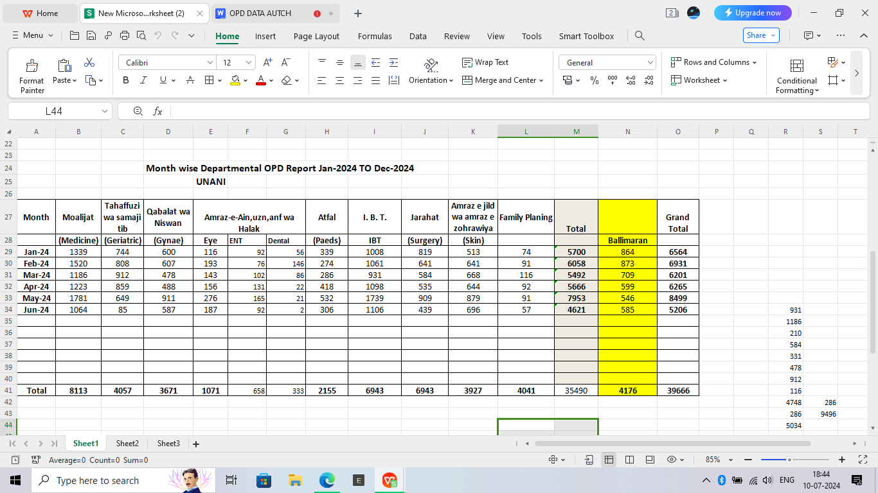

|  |  |  |  |  |  |  |  |  |
| --- | --- | --- | --- | --- | --- | --- | --- | --- |
|  | **Ayurved** |  |  |  |  | **Unani** |  |  |
|  |  |  |  |  |  |  |  |  |
| **MONTH** | **New** | **OLD** | **Total** |  | **MONTH** | **New** | **OLD** | **Total** |
| Jan-24 | 5536 | 1956 | 7492 |  | Jan-24 | 4848 | 920 | 5768 |
| Frb-24 | 5348 | 3694 | 9042 |  | Frb-24 | 4187 | 1968 | 6155 |
| Mar-24 | **4730** | 4072 | 8802 |  | Mar-24 | **3664** | 1828 | 5492 |
| Apr-24 | 4835 | 3969 | 8804 |  | Apr-24 | 3714 | 1952 | 5666 |
| May-24 | 5167 | 4994 | 10161 |  | May-24 | 4761 | 3192 | 7953 |
| Jun-24 | 3888 | 3648 | 7536 |  | Jun-24 | 2660 | 1961 | 4621 |

**IPD Hospital Central Registration Admission-IPD**

|  |  |  |  |  |  |  |  |  |  |  |  |  |  |  |  |  |  |  |  |  |  |  |  |  |  |  |  |  |  |  |  |  |  |  |  |  |  |  |  |  |  |  |  |  |  |  |  |  |  |  |  |  |  |  |  |  |  |  |  |  |  |  |  |  |  |  |  |  |  |  |  |  |  |  |  |  |  |  |  |  |  |  |  |  |  |  |  |  |  |  |  |  |  |  |  |  |  |
| --- | --- | --- | --- | --- | --- | --- | --- | --- | --- | --- | --- | --- | --- | --- | --- | --- | --- | --- | --- | --- | --- | --- | --- | --- | --- | --- | --- | --- | --- | --- | --- | --- | --- | --- | --- | --- | --- | --- | --- | --- | --- | --- | --- | --- | --- | --- | --- | --- | --- | --- | --- | --- | --- | --- | --- | --- | --- | --- | --- | --- | --- | --- | --- | --- | --- | --- | --- | --- | --- | --- | --- | --- | --- | --- | --- | --- | --- | --- | --- | --- | --- | --- | --- | --- | --- | --- | --- | --- | --- | --- | --- | --- | --- | --- | --- | --- | --- |
| |  | | --- | |  | |  |  | **AYURVEDIC** |  | | **Dept.** | **Jan-23** | **Feb-23** | **TOTAL** | | **Medicine** | 8 | 31 | **39** | | **Geriatrics** | 0 | 0 | **0** | | **Panchkarma** | 14 | 44 | **58** | | **Surgery** | 25 | 47 | **72** | | **ENT** | 0 | 6 | **6** | | **Gynae** | 0 | 0 | **0** | | **Peads** | 2 | 14 | **16** | | **TOTAL** | **49** | **142** | **191** | | |  |  |  |  |  | | --- | --- | --- | --- | --- | |  |  | **Unani** |  |  | | **Dept.** | **Jan-23** | **Feb-23** | **Apr-23** | **TOTAL** | | **Medicine** | 3 | 15 | 10 | **28** | | **IBT** | 4 | 11 | 12 | **27** | | **SKIN** | 0 | 0 | 0 | **0** | | **Geriatrics** | 1 | 7 | 1 | **9** | | **Surgery** | 44 | 21 | 36 | **101** | | **ENT** | 0 | 0 |  | **0** | | **Gynae** | 48 | 62 |  | **110** | | **Peads** | 0 | 11 |  | **11** | | **TOTAL** | **100** | **127** | **59** | **369** | |

**Ayurveda-Admission**

**Report of Ayurvedic patient monthwise admitted in IPD Ward w. e. f. January, 2024 to Dec-2024**

|  |  |  |  |  |  |  |  |  |  |
| --- | --- | --- | --- | --- | --- | --- | --- | --- | --- |
| **Name of Doctors** |  | **IPD Wards** | **Jan** | **Feb** | **March** | **April** | **May** | **June** | **Total** |
| **1. Dr. Praveen Chaudhary** |  | Surgery | 8 | 22 | 14 | 15 | 21 | 7 | 87 |
| **2.Dr. Prashant L.Rasale** |  | Surgery | 6 | 14 | 25 | 3 | 0 | 13 | 61 |
| **3.Dr.Harhit** |  | Surgery | 5 | 9 | 0 | 0 | 0 | 0 | 14 |
|  |  | **Total** | **19** | **45** | **39** | **18** | **21** | **20** | 162 |
| **4. Dr. Sujata Yadav** |  | Medicine | 6 | 7 | 10 | 5 | 2 | 4 | 34 |
| **5. Dr. Umesh Patil** |  | Medicine | 0 | 0 | 0 | 3 | 11 | 2 | 16 |
| **6 Dr. Amit** |  | Medicine | 0 | 0 | 0 | 3 | 12 | 0 | 15 |
| **Dr. Subra jyoti** |  | Medicine | 0 | 0 | 0 | 0 | 12 | 1 | 13 |
| **Dr. Dr. Rashmi** |  | Medicine | 0 | 0 | 0 | 0 | 1 | 0 | 1 |
|  |  | **total** | **6** | **7** | **10** | **11** | **38** | **7** | 79 |
| **5.Dr. B.S Hiremath** |  | Geriataric | 0 | 0 | 0 | 0 | 0 | 0 | 0 |
| **6.Dr. Neelam Gupta** |  | Geriataric | 0 | 0 | 0 | 0 | 0 | 0 | 0 |
| **7.Dr.Nishi Arora** |  | Geriataric | 0 | 0 | 0 | 0 | 0 | 0 | 0 |
|  |  | **Total** | **0** | **0** | **0** | **0** | **0** | **0** | 0 |
| **8. Dr. Haramohan** |  | Eye/ENT | 0 | 4 | 3 | 11 | 17 | 1 | 36 |
| **9. Dr. Rajesh Kr.Chhokar** |  | Eye/ENT | 0 | 0 | 1 | 2 | 0 | 1 | 4 |
| **10. Dr. Poonam** |  | Eye/ENT | 3 | 8 | 3 | 5 | 0 | 3 | 22 |
|  |  | **total** | **3** | **12** | **7** | **18** | **17** | **5** | **62** |
| **11 . Dr. B. S. Sharma** |  | Balrog | 1 | 11 | 7 | 9 | 3 | 6 | 37 |
| **12 .Dr Mukesh** |  | Balrog | 4 | 5 | 7 | 8 | 1 | 4 | 29 |
| **13. Dr. Sonam** |  | Balrog | 0 | 0 | 1 | 1 | 13 | 4 | 19 |
|  |  | **TOTAL** | **5** | **16** | **15** | **18** | **17** | **14** | 85 |
| **12. Dr. Shalini Varshany** |  | Gynae | 0 | 0 | 0 | 0 | 0 | 0 | 0 |
| **13. Dr.Neelam Gupta** |  | Gynae | 0 | 0 | 0 | 0 | 0 | 0 | 0 |
| **14. Dr.Sangeeta Mishra** |  | Gynae | 0 | 0 | 0 | 0 | 0 | 0 | 0 |
| **13. Dr. Monika Tyagi** |  | Gynae | 0 | 0 | 0 | 0 | 0 | 0 | 0 |
|  |  | **TOTAL** | **0** | **0** | **0** | **0** | **0** | **0** | 0 |
| **14. Dr. Manoj Shamkuwar** |  | Panchakarma | 5 | 10 | 9 | 16 | 22 | 1 | 63 |
| **15. Dr. Sruti** |  | Panchakarma | 9 | 4 | 11 | 12 | 2 | 14 | 52 |
| **16. Dr. Nitin Jindal** |  | Panchakarma | 6 | 15 | 18 | 29 | 32 | 15 | 115 |
|  |  | **TOTAL** | **20** | **29** | **38** | **57** | **56** | **30** | 230 |
| **17. Dr. Rajesh Shamra** |  |  | 0 | 0 | 0 | 0 | 0 | 0 | 0 |
| **18.Dr. Monika Tyagi** |  | Ekal Dravya Vibhag | 0 | 0 | 0 | 0 | 0 | 0 | 0 |
| **19. Dr. Bansidhar Behra** |  | 0 | 0 | 0 | 0 | 0 | 0 | 0 |
| **20. Dr.Shalini Varshany** |  | 0 | 0 | 0 | 0 | 0 | 0 | 0 |
| **21. Dr. Shilpa Walkikar** |  | 0 | 0 | 0 | 0 | 0 | 0 | 0 |
| **22. Dr. Kiran Nimbalkar** |  | 0 | 0 | 0 | 0 | 0 | 0 | 0 |
|  |  | TOTAL | 0 | 0 | 0 | 0 | 0 | 0 | 0 |
| **Total** |  |  | **53** | **109** | **109** | **122** | **149** | **76** | 618 |

|  |  |  |  |  |  |  |  |  |  |
| --- | --- | --- | --- | --- | --- | --- | --- | --- | --- |
|  |  |  | **Unani-Admission** |  |  |  |  |  |  |
| **Report of Unani patient monthwise admitted in IPD Ward w. e. f. January, 2024 to Dec-2024** | | | | | | | | | |

|  |  |  |  |  |  |  |  |  |  |
| --- | --- | --- | --- | --- | --- | --- | --- | --- | --- |
| **Name of Doctors** |  | **IPD Wards** | **Jan** | **Feb** | **March** | **April** | **May** | **June** | **Total** |
| **1. Dr. Aysha Raza** |  | Gynae | 38 | 41 | 26 | 30 | 64 | 39 | 238 |
| **2. Dr. Suboohi Irshad** |  | Gynae | 6 | 8 | 5 | 15 | 19 | 4 | 57 |
| **3. Dr. Shahana** |  | Gynae | 8 | 13 | 11 | 22 | 9 | 6 | 69 |
|  |  | **Total** | **52** | **62** | **42** | **67** | **92** | **49** | **364** |
| **4 .Dr. N.A. Khan** |  | Medicine | 8 | 14 | 6 | 5 | 22 | 8 | 63 |
| **5.Dr.Nusrat** |  | Medicine | 8 | 9 | 5 | 2 | 7 | 12 | 43 |
| **6. Dr. Mubarak Ali** |  | Medicine | 2 | 0 | 1 | 2 | 10 | 3 | 18 |
|  |  | **Total** | **18** | **23** | **12** | **9** | **39** | **23** | **124** |
| **7. Dr. Ansari Shabnam** |  | Geriataric | 0 | 0 | 0 | 0 | 0 | 0 | 0 |
| **8. Dr. Farooqe** |  | Geriataric | 0 | 0 | 0 | 0 | 0 | 0 | 0 |
| **9. Dr. Suboohi Irshad** |  | Geriataric | 0 | 0 | 0 | 0 | 0 | 0 | 0 |
|  |  | **Total** | **0** | **0** | **0** | **0** | **0** | **0** | **0** |
| **10. Dr. Arshad Ansari** |  | I.B.T | 6 | 13 | 8 | 10 | 29 | 4 | 70 |
| **11. DR. Fatima** |  | I.B.T | 0 | 2 | 1 | 9 | 2 | 5 | 19 |
|  |  | **Total** | **6** | **15** | **9** | **19** | **31** | **9** | **89** |
| **11. Dr. Aaliya** |  | Skin | 0 | 0 | 0 | 2 | 3 | 0 | 5 |
| **12. Dr. Hamid Ali** |  | Skin | 0 | 0 | 7 | 3 | 0 | 0 | 10 |
|  |  | **Total** | **0** | **0** | **7** | **5** | **3** | **0** | **15** |
| **13. Dr. Abdul Nasir** |  | Surgery | 19 | 31 | 27 | 27 | 32 | 0 | 136 |
| **14. Dr. Daraksha Khanam** |  | Surgery | 7 | 6 | 10 | 8 | 1 | 5 | 37 |
|  |  | **Total** | **26** | **37** | **37** | **35** | **33** | **5** | **173** |
| **15. Dr. Fahmida Kausar** |  | Atfal | 3 | 8 | 7 | 5 | 31 | 2 | 56 |
| **16. Dr. Naghma chand** |  | Atfal | 14 | 8 | 12 | 14 | 3 | 4 | 55 |
|  |  | **Total** | **17** | **16** | **19** | **19** | **34** | **6** | **111** |
| **17. Dr. Adnan** |  | Eye/Ent. | 2 | 4 | 5 | 3 | 2 | 4 | 20 |
| **18.Dr. Mahmood Ahmad** |  | Eye/Ent. | 2 | 0 | 2 | 3 | 8 | 1 | 16 |
|  |  | **Total** | **4** | **4** | **7** | **6** | **10** | **5** | **36** |
| **19. Dr.Nauman Saleem** |  | Family Planning(Munafe-Ul-Aza | 0 | 0 | 0 | 0 | 0 |  | 0 |
| **20. Dr. Shahana Ayub** |  | 0 | 0 | 0 | 0 | 0 |  | 0 |
| **21. Dr. Suboohi Irshad** |  | 0 | 0 | 0 | 0 | 0 |  | 0 |
| **22. Dr. Nazmeen** |  | 0 | 0 | 0 | 0 | 0 |  | 0 |
|  |  | **Total** | **0** | **0** | **0** | **0** | **0** | **0** | **0** |
|  |  |  | **123** | **157** | **133** | **160** | **242** | **97** | 912 |

**Ayurveda-Bed Occupancy**

**Report of Ayurvedic patient monthwise admitted in IPD Ward w. e. f. January, 2024 to Dec-2024**

|  |  |  |  |  |  |  |  |  |  |
| --- | --- | --- | --- | --- | --- | --- | --- | --- | --- |
| **Name of Doctors** |  | **IPD Wards** | **Jan** | **Feb** | **March** | **April** | **May** | **June** | **Total** |
| **1. Dr. Praveen Chaudhary** |  | **Surgery** | 15 | 37 | 25 | 27 | 37 | 11 | **152** |
| **2.Dr. Prashant L.Rasale** |  | **Surgery** | 7 | 32 | 36 | 3 | 0 | 14 | **92** |
| **3.Dr.Harhit** |  | **Surgery** | 11 | 14 | 0 | 0 | 0 | 0 | **25** |
| **TOTAL** |  |  | **33** | **83** | **61** | **30** | **37** | **25** | **269** |
| **4. Dr. Sujata Yadav** |  | **Medicine** | 54 | 41 | 57 | 31 | 33 | 7 | **223** |
| **8. Dr. Amit** |  | **medicine** | 0 | 0 | 0 | 30 | 87 | 25 | **142** |
| **1. Dr. Rashmi** |  | **medicine** | 0 | 0 | 0 | 0 | 2 | 0 | **2** |
| **Dr. Umesh** |  | **medicine** | 0 | 0 | 0 | 7 | 0 | 9 | **16** |
| **dr. subra jyoti** |  | **medicine** | 0 | 0 | 0 | 0 | 74 | 20 | **94** |
| **TOTAL** |  |  | **54** | **41** | **57** | **68** | **196** | **61** | **383** |
| **5.Dr. B.S Hiremath** |  | **Geriataric** | 0 | 0 | 0 | 0 | 0 | 0 | **0** |
| **6.Dr. Neelam Gupta** |  | **Geriataric** | 0 | 0 | 0 | 0 | 0 | 0 | **0** |
| **7. Dr.Nishi Arora** |  | **Geriataric** | 0 | 0 | 0 | 0 | 0 | 0 | **0** |
| **TOTAL** |  |  | **0** | **0** | **0** | **0** | **0** | **0** | **0** |
| **8. Dr. Haramohan** |  | **Eye/ENT** | 8 | 42 | 32 | 86 | 192 | 43 | **403** |
| **9. Dr. Rajesh Kr.Chhokar** |  | **Eye/ENT** | 16 | 0 | 23 | 39 | 0 | 4 | **82** |
| **10. Dr. Poonam** |  | **Eye/ENT** | 31 | 94 | 117 | 50 | 27 | 20 | **339** |
| **TOTAL** |  |  | **55** | **136** | **172** | **175** | **219** | **67** | **824** |
| **11 . Dr. B. S. Sharma** |  | **Balrog** | 30 | 133 | 176 | 91 | 94 | 36 | **560** |
| **12 .Dr Mukesh** |  | **Balrog** | 56 | 74 | 110 | 92 | 45 | 20 | **397** |
| **13. DR. Sonam** |  | **Balrog** | 0 | 0 | 5 | 7 | 134 | 54 | **200** |
| **TOTAL** |  |  | **86** | **207** | **291** | **190** | **273** | **110** | **1157** |
| **12. Dr. Shalini Varshany** |  | **Gynae** | 0 | 0 | 0 | 0 | 0 | 0 | **0** |
| **13. Dr.Neelam Gupta** |  | **Gynae** | 0 | 0 | 0 | 0 | 0 | 0 | **0** |
| **14. Dr.Sangeeta Mishra** |  | **Gynae** | 0 | 0 | 0 | 0 | 0 | 0 | **0** |
| **13. Dr. Monika Tyagi** |  | **Gynae** | 0 | 0 | 0 | 0 | 0 | 0 | **0** |
| **TOTAL** |  |  | **0** | **0** | **0** | **0** | **0** | **0** | **0** |
| **14. Dr. Manoj Shamkuwar** |  | **Panchakarma** | 120 | 93 | 83 | 196 | 288 | 16 | **796** |
| **15. Dr. Sruti** |  | **Panchakarma** | 70 | 52 | 103 | 144 | 62 | 120 | **551** |
| **16. Dr. Nitin Jindal** |  | **Panchakarma** | 52 | 152 | 163 | 337 | 351 | 267 | **1322** |
| **TOTAL** |  |  | **242** | **297** | **349** | **677** | **701** | **403** | **2669** |
| **17. Dr. Rajesh Shamra** |  |  | 0 | 0 | 0 | 0 | 0 | 0 | **0** |
| **18.Dr. Monika Tyagi** |  | **Ekal Dravya Vibhag** | 0 | 0 | 0 | 0 | 0 | 0 | **0** |
| **19. Dr. Bansidhar Behra** |  | 0 | 0 | 0 | 0 | 0 | 0 | **0** |
| **20. Dr.Shalini Varshany** |  | 0 | 0 | 0 | 0 | 0 | 0 | **0** |
| **21. Dr. Shilpa Walkikar** |  | 0 | 0 | 0 | 0 | 0 | 0 | **0** |
| **22. Dr. Kiran Nimbalkar** |  | 0 | 0 | 0 | 0 | 0 | 0 | **0** |
| **TOTAL** |  |  | **0** | **0** | **0** | **0** | **0** | **0** | **0** |
| **Total** |  |  | **470** | **764** | **930** | **1140** | **1426** | **666** | **5396** |

**Unani-Bed Occupancy**

**Report of Unani patient admitted in IPD Ward w. e. f. January, 2024 to Dec-2024**

|  |  |  |  |  |  |  |  |  |
| --- | --- | --- | --- | --- | --- | --- | --- | --- |
| **Name of Doctors** | **IPD Wards** | **Jan** | **Feb** | **March** | **April** | **May** | **June** |  |
| **1. Dr. Aysha Raza** | **Gynae** | 288 | 295 | 218 | 132 | 391 | 248 |  |
| **2. Dr. Suboohi Irshad** | **Gynae** | 28 | 54 | 20 | 45 | 51 | 38 |  |
| **3. Dr. Shahana** | **Gynae** | 22 | 31 | 23 | 26 | 11 | 20 |  |
| **TOTAL** |  | **338** | **380** | **261** | **203** | **453** | **306** |  |
| **4 .Dr. N.A. Khan** | **Medicine** | 48 | 90 | 33 | 5 | 140 | 40 |  |
| **5.Dr.Nusrat** | **Medicine** | 33 | 21 | 28 | 10 | 13 | 50 |  |
| **6. Dr. Mubarak Ali** | **Medicine** | 6 | 0 | 2 | 12 | 47 | 36 |  |
| **TOTAL** |  | **87** | **111** | **63** | **27** | **200** | **126** |  |
| **7. Dr. Ansari Shabnam** | **Geriataric** | 0 | 0 | 0 | 0 |  | 0 |  |
| **8. Dr. Farooqe** | **Geriataric** | 0 | 0 | 0 | 0 | 0 | 0 |  |
| **9. Dr. Suboohi Irshad** | **Geriataric** | 0 | 0 | 0 | 0 | 0 | 0 |  |
| **TOTAL** |  | **0** | **0** | **0** | **0** | **0** | **0** |  |
| **10. Dr. Arshad Ansari** | **I.B.T** | 81 | 90 | 127 | 70 | 254 | 52 |  |
| **11. DR. Fatima** | **I.B.T** | 0 | 2 | 33 | 44 | 37 | 23 |  |
| **TOTAL** |  | **81** | **92** | **160** | **114** | **291** | **75** |  |
| **11. Dr. Aaliya** | **Skin** | 0 | 0 | 0 | 3 | 15 | 0 |  |
| **12. Dr. Hamid Ali** | **Skin** | 0 | 0 | 33 | 12 | 0 | 0 |  |
| **TOTAL** |  | **0** | **0** | **33** | **15** | **15** | **0** |  |
| **13. Dr. Abdul Nasir** | **Surgery** | 12 | 26 | 26 | 14 | 52 | 0 |  |
| **14. Dr. Daraksha Khanam** | **Surgery** | 10 | 7 | 20 | 37 | 5 | 5 |  |
| **TOTAL** |  | **22** | **33** | **46** | **51** | **57** | **5** |  |
| **15. Dr. Fahmida Kausar** | **Atfal** | 15 | 28 | 11 | 23 | 134 | 0 |  |
| **16. Dr. Naghma chand** | **Atfal** | 59 | 30 | 27 | 36 | 20 | 6 |  |
| **TOTAL** |  | **74** | **58** | **38** | **59** | **154** | **6** |  |
| **17. Dr. Adnan** | **Eye/Ent.** | 1 | 1 | 3 | 3 | 3 | 4 |  |
| **18.Dr. Mahmood Ahmad** | **Eye/Ent.** | 6 | 0 | 2 | 4 | 25 | 1 |  |
| **TOTAL** |  | **7** | **1** | **5** | **7** | **28** | **5** |  |
| **19. Dr.Nauman Saleem** | **Family Planning(Munafe-Ul-Aza** | 0 | 0 | 0 | 0 | 0 | 0 |  |
| **20. Dr. Shahana Ayub** | 0 | 0 | 0 | 0 | 0 | 0 |  |
| **21. Dr. Suboohi Irshad** | 0 | 0 | 0 | 0 | 0 | 0 |  |
| **22. Dr. Nazmeen** | 0 | **0** | **0** | **0** | **0** | **0** |  |
| **TOTAL** |  | 0 | 0 | 0 | 0 | 0 | 0 |  |
|  |  | **609** | **675** | **606** | **476** | **1198** | **523** |  |
| **Monthly Department wise IPD Bed- Occupancy January, 2024 to Dec-2024**  **Unani Section** | | | | | | | | |
| **Month** | **Moalijat** | **Jarahat** | **Qabalat wa Niswas** | **Amraz-e-Ain,uzn,anaf wa Halaq** | **Atfal** | **Tahaffuziwa samaji Tib** | **Amraz-e-jildwa-amraz-zohrawiya** | **Ilaj Bil Tadbeer** | **Total** |
|  | **(Medicine)** | **(Surgery)** | **(Gynae)** | **(Eye/Ent)** | **(Peads)** | **(Geriatric)** | **(Skin)** | **(IBT)** |  |
| **Jan-24** | 87 | 22 | 338 | 7 | 74 | 0 | 0 | 81 | **609** |
| **Feb-24** | 111 | 33 | 380 | 1 | 58 | 0 | 0 | 92 | **675** |
| **Mar-24** | 63 | 46 | 261 | 5 | 38 | 0 | 33 | 160 | **606** |
| **Apr-24** | 27 | 51 | 203 | 7 | 59 | 0 | 15 | 114 | **476** |
| **May-24** | 200 | 57 | 453 | 28 | 154 | 0 | 15 | 291 | **1198** |
| **Jun-24** | 126 | 5 | 306 | 5 | 6 | 0 | 0 | 75 | **523** |
| **Jul-24** | 0 | 0 | 0 | 0 | 0 | 0 | 0 | 0 | **0** |
| **Aug-24** | 0 | 0 | 0 | 0 | 0 | 0 | 0 | 0 | **0** |
| **Sep-24** | 0 | 0 | 0 | 0 | 0 | 0 | 0 | 0 | **0** |
| **Oct-24** | 0 | 0 | 0 | 0 | 0 | 0 | 0 | 0 | **0** |
| **Nov-24** | 0 | 0 | 0 | 0 | 0 | 0 | 0 | 0 | **0** |
| **Dec-24** | 0 | 0 | 0 | 0 | 0 | 0 | 0 | 0 | **0** |
| **Total** | **614** | **214** | **1941** | **53** | **389** | **0** | **63** | **813** | **4087** |

**Monthly Department wise IPD Bed- Occupancy January, 2024 to Dec-2024**

**Ayurveda Section**

|  |  |  |  |  |  |  |  |  |  |
| --- | --- | --- | --- | --- | --- | --- | --- | --- | --- |
| *Month* | *EKAL DRAVYA VIBHAG* | *Kayachikitsa* | *Shalya-tantra* | *Stri Rog/Prasuti Tantra* | *Shalakya Tantra* | *Kaumarbhritya/Balrog* | *PanchKarma* | *Vardhakya* | *Total* |
|  |  | *(Medicine)* | *(Surgery)* | *(Gynea)* | *(Eye/Ent)* | *(Paeds)* |  | *(Giriatrics)* |  |
| *Jan-24* | *0* | *54* | *33* | *0* | *55* | *86* | *242* | *0* | *470* |
| *Feb-24* | *0* | *41* | *83* | *0* | *136* | *207* | *297* | *0* | *764* |
| *Mar-24* | *0* | *57* | *61* | *0* | *172* | *291* | *349* | *0* | *930* |
| *Apr-24* | *0* | *68* | *30* | *0* | *175* | *190* | *677* | *0* | *1140* |
| *May-24* | *0* | *196* | *37* | *0* | *219* | *273* | *701* | *0* | *1426* |
| *Jun-24* | *0* | *61* | *25* | *0* | *67* | *110* | *403* | *0* | *666* |
| *Jul-24* | *0* | *0* | *0* | *0* | *0* | *0* | *0* | *0* | *0* |
| *Aug-24* | *0* | *0* | *0* | *0* | *0* | *0* | *0* | *0* | *0* |
| *Sep-24* | *0* | *0* | *0* | *0* | *0* | *0* | *0* | *0* | *0* |
| *Oct-24* | *0* | *0* | *0* | *0* | *0* | *0* | *0* | *0* | *0* |
| *Nov-24* | *0* | *0* | *0* | *0* | *0* | *0* | *0* | *0* | *0* |
| *Dec-24* | *0* | *0* | *0* | *0* | *0* | *0* | *0* | *0* | *0* |
| *Total* | *0* | *477* | *269* | *0* | *824* | *1157* | *2669* | *0* | *5396* |

**Monthly Department wise IPD Report (Admissions) January, 2024 to Dec-2024**

|  |  |  |  |  |  |  |  |  |
| --- | --- | --- | --- | --- | --- | --- | --- | --- |
| *Month* | *Kayachikitsa* | *Vardhakya* | *Stri -Rog&* | *Shalakya* | *kaumarbhritya* | *Panchakarma* | *Shalya* | *Total* |
|  |  |  | *Prasuti* | *Tantra* | */Balrog* |  | *Tantra* |  |
|  | *(Medicine)* | *(Geriatrics)* | *Tantra(Gynae)* | *(Eye/ENT)* | *(Peads)* |  | *(Surgery)* |  |
| *Jan-24* | *6* | *0* | *0* | *3* | *5* | *20* | *19* | *53* |
| *Feb-24* | *7* | *0* | *0* | *12* | *16* | *29* | *45* | *109* |
| *Mar-24* | *10* | *0* | *0* | *7* | *15* | *38* | *39* | *109* |
| *Apr-24* | *11* | *0* | *0* | *18* | *18* | *57* | *18* | *122* |
| *May-24* | *38* | *0* | *0* | *17* | *17* | *56* | *21* | *149* |
| *Jun-24* | *7* | *0* | *0* | *5* | *14* | *30* | *20* | *76* |
| *Total* | *79* | *0* | *0* | *62* | *85* | *230* | *162* |  |

|  |  |  |  |  |  |  |  |  |  |
| --- | --- | --- | --- | --- | --- | --- | --- | --- | --- |
| Monthly **Department wise IPD** Report January, 2024 to Dec-2024**(Admissions)** | | | | | | | | |  |
|  |  |  |  |  | **Unani Saction** |  |  |  |  |
| **Month** | **Moalijat** | **Tahaffuzi wa samaji tib** | **Qabalat wa Niswan** | **Amraz-e-Ain** | **Atfal** | **Jarahat** | **Amraz-e-jild** | **Ilaj-Bil-** | **Total** |
| **Uzn,Anaf wa Halaq** | **wa-amraz-e** | **Tadbeer** |
| **(Medicine)** | **(Geriatric)** | **(Gynaec)** | **(eye/ENT)** | **(Paeds)** | **(Surgery)** | **Zohrawiya(Skin)** | **IBT** |  |
| **Jan-24** | **18** | **0** | **52** | **4** | **17** | **26** | **0** | **6** | **123** |
| **Feb-24** | 23 | 0 | **62** | 4 | 16 | 37 | 0 | 15 | **157** |
| **Mar-24** | 12 | 0 | **42** | 7 | 19 | 37 | 7 | 9 | **133** |
| **Apr-24** | 9 | 0 | **67** | 6 | 19 | 35 | 5 | 19 | **160** |
| **May-24** | 39 | 0 | **92** | 10 | 34 | 33 | 3 | 31 | **242** |
| **Jun-24** | 23 | 0 | **49** | 5 | 6 | 5 | 0 | 9 | **97** |
| **Jul-24** | 0 | 0 | **0** | 0 | 0 | 0 | 0 | 0 | **0** |
| **Aug-24** | 0 | 0 | **0** | 0 | 0 | 0 | 0 | 0 | **0** |
| **Sep-24** | 0 | 0 | **0** | 0 | 0 | 0 | 0 | 0 | **0** |
| **Oct-24** | 0 | 0 | **0** | 0 | 0 | 0 | 0 | 0 | **0** |
| **Nov-24** | 0 | 0 | **0** | 0 | 0 | 0 | 0 | 0 | **0** |
| **Dec-24** | 0 | 0 | **0** | 0 | 0 | 0 | 0 | 0 | **0** |
| **Total** | **124** | **0** | **364** | **36** | **111** | **173** | **15** | **89** | **912** |