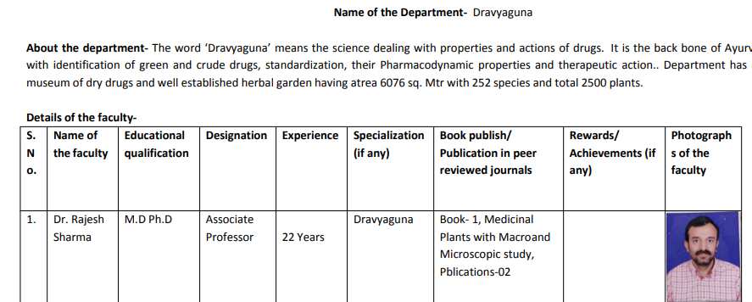

Name of Department |  | Department of Dravyaguna
Details of Faculties
Name |  | Dr. Shalini Varshney
Date of Birth |  | 01.03.1976
Photo |  | 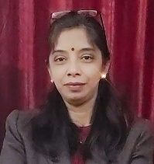
Teacher Code |  | AYDG01002
Reg. No. |  | 59009 (Board of Aturvedic and Unani Tibbi System UP)
Edu. Qualification |  | M.D(Ayu), Ph. D. (Persuing), CRAV
Designation |  | Associate Professor
Date of Joining |  | 13.04.2016
Experience |  | 18years
Contact No. |  | 9354925050, 9897536348
Email-id |  | shalinidr.v7@gmail.com, shalinivarshney.22@delhi.gov.in
List of Research Publications |  | Review and Research Articles-30
OPD days and timings |  | Wednesday, Friday (9:00am-1:00pm)
PG Department present /absent |  | Present
List of Students and Thesis Title |  | List of PG Scholars and Thesis Topics
  Sr. No. | Name of PG Scholar | Topic of Thesis
  1 | Dr. Monika Kunwar | Pharmacognostical and Antifungal Activity (In Vitro) and Clinical Efficacy of Bhurjah (Betula utilis D. Don) in Dadru Kushta (Dermatophytosis) – A Pilot Study
  2 | Dr. Rishabh Rathore | Evaluation of Hypoglycaemic Activity (In Vitro) and Clinical Efficacy of Panch Tikta Churna in Madhumeha (Type 2 Diabetes Mellitus)
  3 | Dr. Sabahat Anjum | Pharmaceutical Development, Standardisation and Clinical Evaluation of Efficacy of Arjuna, Manjishta, and Vasa (AMV) Lepa and Cream in Vyanga (Melasma)
  4 | Dr. Sandhya Maravi | Evaluation of Clinical Efficacy of Yashtimadhu (Oral and Topical) Application in Mukhdushika (Acne) – An Exploratory Study
  5 | Dr. Deepika | Clinical Efficacy of Karchur Rhizomes (Curcuma zedoaria Rosc.) Vati in Hypothyroidism (Dhatvagnimandya) – An Exploratory Study
  6 | Dr. Ashim Aryan | Pharmacognostical, Analytical Evaluation and Clinical Efficacy of Nirgundi (Vitex negundo Linn.) Leaves (Water-Soluble Extract) in the Management of Sthaulya – A Randomized Placebo-Controlled Trial
  7 | Dr. Korbu Nilofar Shahajan | Pharmacognostical and Analytical Study of Bhanga (Cannabis sativa Linn.) Seeds from Different Market Samples, with In-Silico and In-Vitro Assessment of Analgesic and Anti-inflammatory Properties in the Context of Amavata (Rheumatoid Arthritis)
CME Seminars/Conferences etc.  Programmes conducted by Department |  | CME for teachers of Dravyaguna in 2017
Any awards or appreciations received, if any |  | “Ashwagandha Champ”  by Directorate of AYUSH for distribution of Aswagandha saplings, project from NMPB.

Name of Department |  | Department of Dravyaguna
Details of Faculties
Name |  | Dr. Banshidhar Behera
Date of Birth |  | 16.06.1974
Photo |  | 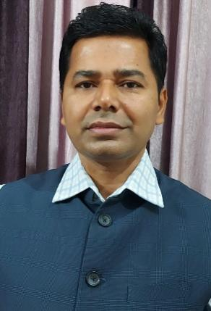
Teacher Code |  | AYDG00979
Reg. No. |  | 4865, Orissa State Council of Ayurvedic Medicine
Edu. Qualification |  | M.D., Ph.D, PGDCR
Designation |  | Associate Professor
Date of Joining |  | 31.03.2016
Experience |  | 16.5 years
Contact No. |  | 9414458895
Email-id |  | drbanshi@rediffmail.com
List of Research Publications |  | Research Articles-23, Book Chapters-10, Book-4
OPD days and timings |  | Wednesday, Thursday (9:00am-1:00pm)
PG Department present /absent |  | Present
List of Students and Thesis Title |  | As mentioned previous
CME Seminars/Conferences etc.  Programmes conducted by Department |  | As mentioned previous
Any awards or appreciations received, if any |  | As mentioned previous
Department Speciality in brief |  | As mentioned previous

Name of Department |  | Department of Dravyaguna
Details of Faculties
Name |  | Dr. Monika Tyagi
Date of Birth |  | 20.11.1980
Photo |  | 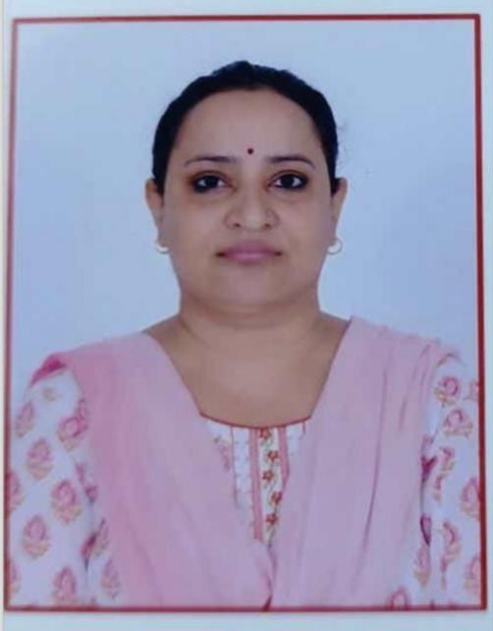
Teacher Code |  | AYDG01154
Reg. No. |  | 49216, Board of ayurvedic and unani tibbi systems of Medicine, UP
Edu. Qualification |  | BAMS, MD, PhD
Designation |  | Assistant professor
Date of Joining |  | 17.09.2010
Experience |  | 15 years 7 months
Contact No. |  | 9354925054
Email-id |  | dr.monika0@gmail.com
List of Research Publications |  | 12 articles
OPD days and timings |  | Wednesday, 9:00 am to 1:00 pm
PG Department present /absent |  | Present
List of Students and Thesis Title |  | Dr. Isha Sharma – Phytochemical and clinical evaluation of Padmaka (Prunus cerasoides D. Don) in the management of Stanyakshaya.  Dr. Dixha Chauhan – Pharmacognostical and phytochemical evaluation of Folklore plant Kadvi booti (Ainsliaea aptera DC.) in the management of Amlapitta w.s.r. to Hyperacidity.  Dr. Bhuraji Narware – Phytochemical study and therapeutic evaluation of Palash pushpa churna in the management of Grahani roga.
CME Seminars/Conferences etc.  Programmes conducted by Department |  | Departmental Seminar
Any awards or appreciations received, if any |  | No
Department Speciality in brief |  | Dravyaguna is a branch of Ayurveda and a core subject which deals with various drugs of natural origin, their identification, collection, storage, preservation, properties and therapeutic actions. Department of Dravyaguna in our college is specialised in several areas and carries out teaching, research activities and health care as well. It is considered as the backbone of Ayurveda Chikitsa. Fundamental principles of Dravyaguna including teachings of topics such as controversial and unidentified drugs, substitutes, adulterants are the main areas focussed and various researches are conducted for the students of M.D.(Ayu). The Department has upgraded to Post Graduation Course from Academic Year 2020.  The Department of Dravyaguna provides assistance and co-operation for the students in the field of pharmacognostical, analytical, pharmacological and pharmaceutical areas whenever needed in their respective research. The Departmental Museum consists of preserved wet specimens as well as dry samples along with Aahar Dravyas for further references. Seminars are conducted on regular intervals in the department and plantation drive is carried out by the Department of Dravyaguna. It has well established herbal gardens with various plant species that are marked with their respective botanical names. Departmental laboratory is well maintained with instruments which are required for pharmacognostical study & research purpose of the PG students.

