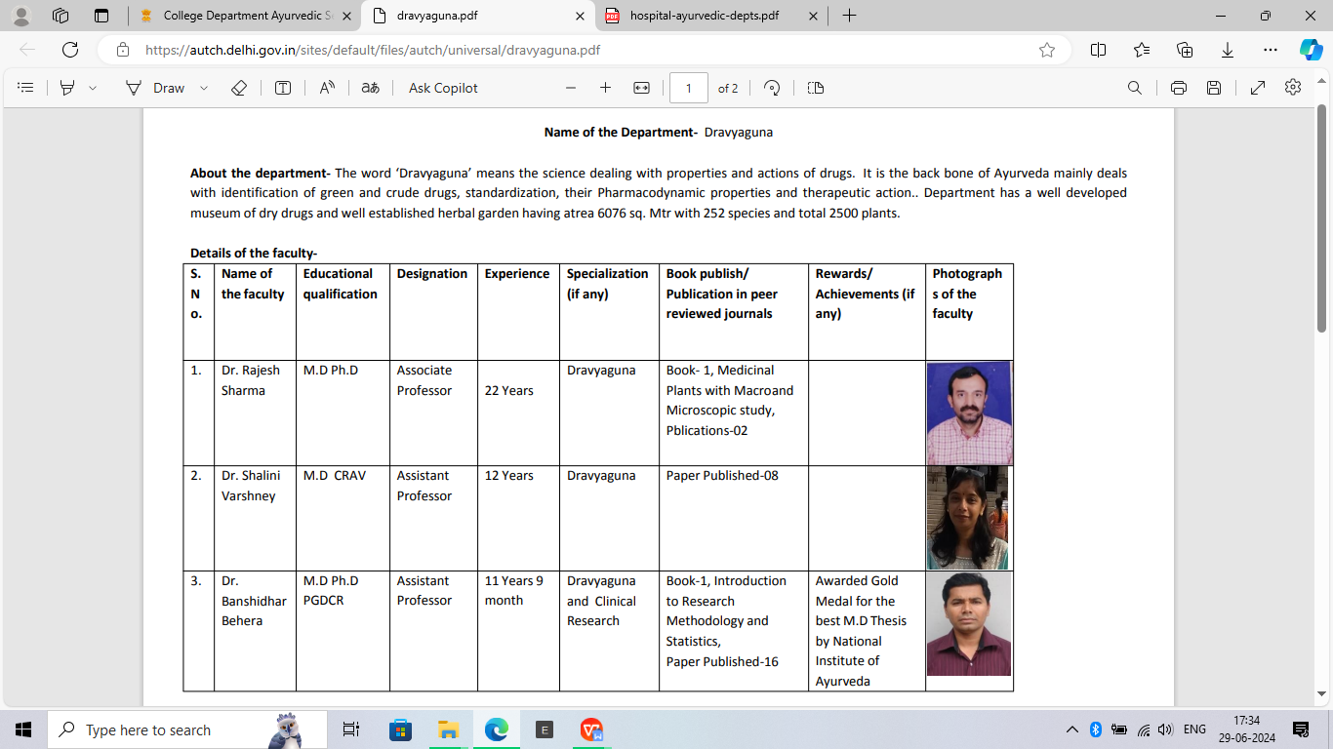

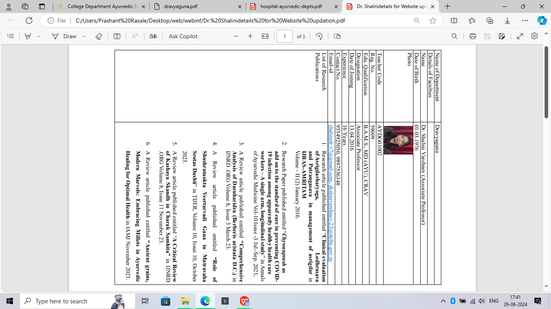

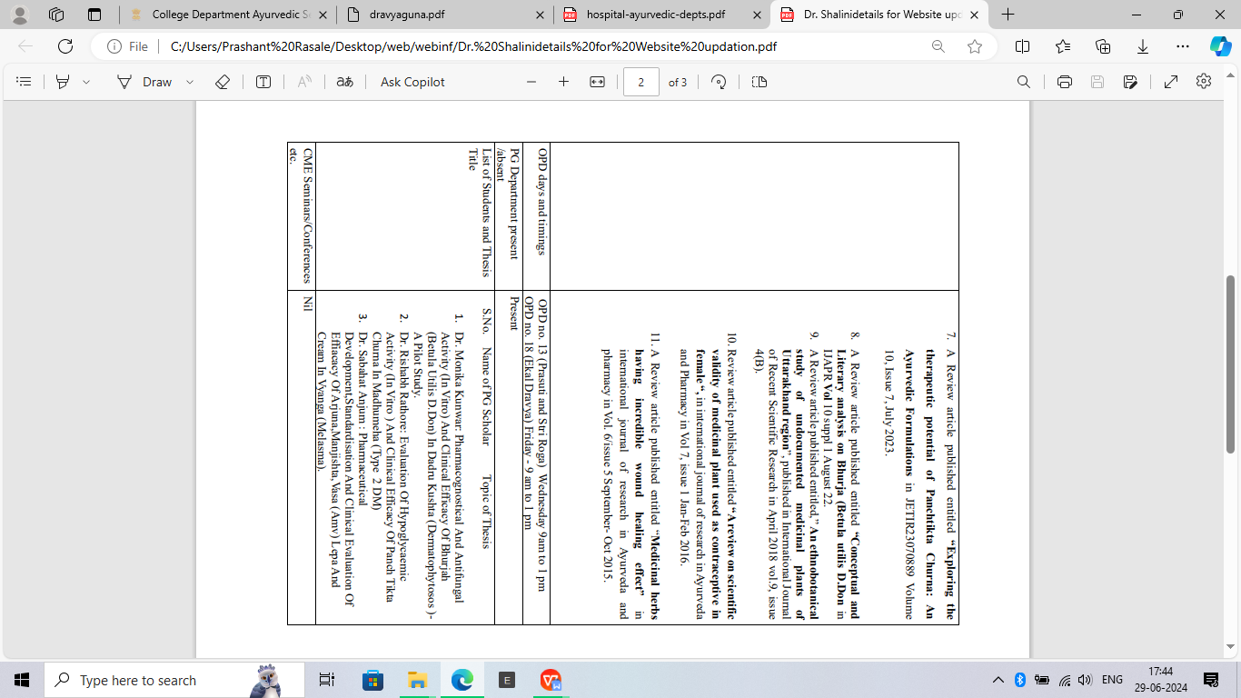

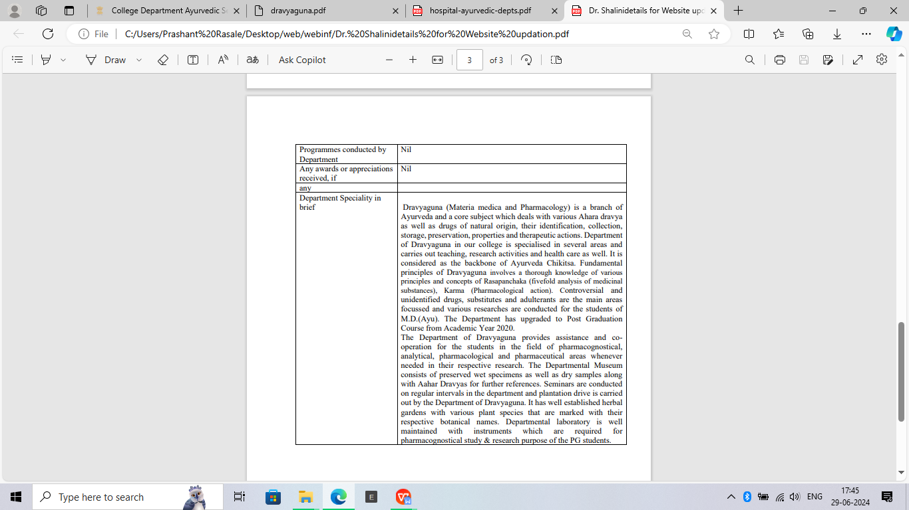

|  |  |  |
| --- | --- | --- |
| Name of Department |  | Department of Dravyaguna |
| Details of Faculties |  |  |
| Name |  | Dr. Banshidhar Behera |
| Date of Birth |  | 16.06.1974 |
| Photo |  |  |
| Teacher Code |  | AYDG00979 |
| Reg. No. |  | 4865, Orissa State Council of Ayurvedic Medicine |
| Edu. Qualification |  | M.D., Ph.D, PGDCR |
| Designation |  | Associate Professor |
| Date of Joining |  | 31.03.2016 |
| Experience |  | 16.5 years |
| Contact No. |  | 9414458895 |
| Email-id |  | drbanshi@rediffmail.com |
| List of Research Publications |  | Research Articles-23, Book Chapters-10, Book-4 |
| OPD days and timings |  | Wednesday, Thursday (9:00am-1:00pm) |
| PG Department present /absent |  | Present |
| List of Students and Thesis Title |  | As mentioned previous |
| CME Seminars/Conferences etc.  Programmes conducted by Department | |
| Any awards or appreciations received, if any | |
| Department Speciality in brief | |

|  |  |  |
| --- | --- | --- |
| Name of Department |  | Department of Dravyaguna |
| Details of Faculties |  |  |
| Name |  | Dr. Monika Tyagi |
| Date of Birth |  | 20.11.1980 |
| Photo |  |  |
| Teacher Code |  | AYDG01154 |
| Reg. No. |  | 49216, Board of ayurvedic and unani tibbi systems of Medicine, UP |
| Edu. Qualification |  | BAMS, MD, PhD |
| Designation |  | Assistant professor |
| Date of Joining |  | 17.09.2010 |
| Experience |  | 15 years 7 months |
| Contact No. |  | 9354925054 |
| Email-id |  | dr.monika0@gmail.com |
| List of Research Publications |  | 12 articles |
| OPD days and timings |  | Wednesday, 9:00 am to 1:00 pm |
| PG Department present /absent |  | Present |
| List of Students and Thesis Title |  | **Dr. Isha Sharma** – Phytochemical and clinical evaluation of *Padmaka* (*Prunus cerasoides* D. Don) in the management of *Stanyakshaya.*  **Dr. Dixha Chauhan –** Pharmacognostical and phytochemical evaluation of Folklore plant *Kadvi booti* (*Ainsliaea aptera* DC.) in the management of *Amlapitta* w.s.r. to Hyperacidity.  **Dr. Bhuraji Narware –** Phytochemical study and therapeutic evaluation of *Palash pushpa* *churna* in the management of *Grahani roga.* |
| CME Seminars/Conferences etc.  Programmes conducted by Department | | Departmental Seminar |
| Any awards or appreciations received, if any | | No |
| Department Speciality in brief | | Dravyaguna is a branch of Ayurveda and a core subject which deals with various drugs of natural origin, their identification, collection, storage, preservation, properties and therapeutic actions. Department of Dravyaguna in our college is specialised in several areas and carries out teaching, research activities and health care as well. It is considered as the backbone of Ayurveda Chikitsa. Fundamental principles of Dravyaguna including teachings of topics such as controversial and unidentified drugs, substitutes, adulterants are the main areas focussed and various researches are conducted for the students of M.D.(Ayu). The Department has upgraded to Post Graduation Course from Academic Year 2020.  The Department of Dravyaguna provides assistance and co-operation for the students in the field of pharmacognostical, analytical, pharmacological and pharmaceutical areas whenever needed in their respective research. The Departmental Museum consists of preserved wet specimens as well as dry samples along with Aahar Dravyas for further references. Seminars are conducted on regular intervals in the department and plantation drive is carried out by the Department of Dravyaguna. It has well established herbal gardens with various plant species that are marked with their respective botanical names. Departmental laboratory is well maintained with instruments which are required for pharmacognostical study & research purpose of the PG students. |