Department of Kulliyat
A & U Tibbia College and Hospital
Karol Bagh, New Delhi-110005
Name of the Department | Kulliyat  (Basic Principles of Unani Medicine)
Details of Faculties | Dr. Sahar Saleem, Dr. Ghayasul Islam Siddiqui
Name of the Faculty member | Dr. Sahar Saleem | 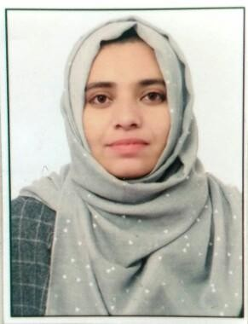
Designation | Assistant Professor
Qualifications | B.U.M.S, M.D.
Date of Birth | 23-05-1990
Registration Number | DBCP/U/9327
Teacher’s Code | UNKL00036
Date of Joining | 19.09.2023
Experience | Total -7 years  - Assistant Professor in D/o Kulliyat at School of Unani Medical Education & Research, Jamia Hamdard, New Delhi-110062 from 27.08.2019 to 04.09.2023.  - Assistant Professor in D/o Mahiyatul Amraz at Hakim Rais Unani Medical College & Hospital  Sambhal , U.P. from 1-1-2018 to 26-08-2019  - Assistant Professor in D/o Munafe-ul-aza at Rajputana Unani Medical College Hospital & Research Centre, Jaipur (Rajasthan) from 22- 02-2017 to 30-12-2017.
Email id | saharsaleem.22@delhi.gov.in  saharsaleem74@gmail.com
Contact No. | 9528659686
OPD Day & Timings | Friday (Hindustani Dawakhana, Ballimaran) 8:00 a.m. to 2:00 p.m
List of Research Publications | ----
PG Department | Absent
List of students & thesis title | ----
CME, Conference, etc program conducted by the department | -----
Awards or appreciation | -----
Department speciality | The Department offers a comprehensive knowledge of all fundamental concepts and general principles of Unani Medicine. With a rich legacy of traditional knowledge, the Department of Kulliyat is involved with teaching and learning of vital and fundamental subjects like Kulliyat Umoor-e-Tabiya, Tareekhe Tib & Urdu, Arabic and Mantiq wa Falsafa at the Undergraduate level.
Dr. Ghayasul Islam Siddiqui
Name of Department | Kulliyat
Details of Faculties
Name | Dr. Ghayasul Islam Siddiqui
Date of Birth | 05-07-1983
Photo | 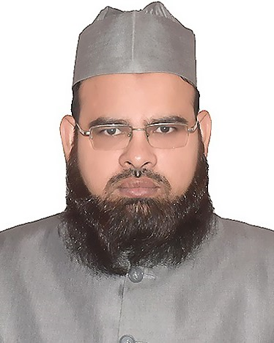
Teacher code | NA
Reg. No. | NA
Edu. Qualification | Ph.D.
Designation | Guest Faculty (As Associate Professor)
Date of Joining | 05-7-2019
Experience | 9 years
Contact No. | 9891050950
Email-id | ghayasul17@gmail.com
Any awards or appreciations received | Prestigious Golden Award from A & U Tibbia College on 8 January 2023

