Name of Department | IlmulAtfal
Details of Faculty | 02 Faculties (Faculty No.1)
Name | Dr.Fahmida Kousar
Date of Birth | 20th May 1974
Photo | 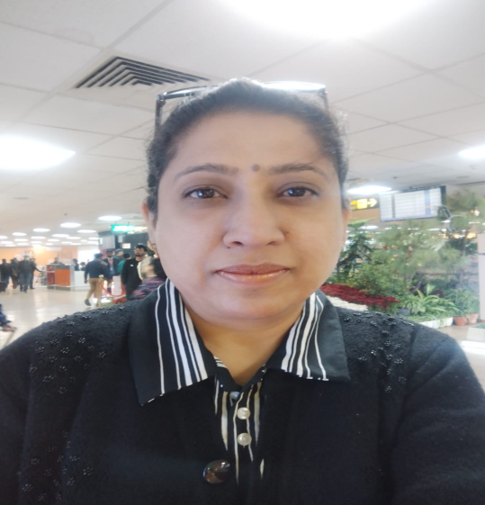
Teacher Code | UNNQ00038
Regd. No. | DBCP/U/6897
Edu. Qualification | B.U.M.S., M.D.(Qabalath O Niswan)
Designation | Associate Professor/ HOD
Date of Joining | 22-10-2008
Experience | 15 years Teaching Experience
Contact No. | 9354925029
Email-id | drfahmida7@yahoo.co.in
List of Research Publications | 1. kousar,F (2023).Individualized Therapy to Manage Quadriplegic Spastic Cerebral Palsy with Unani Treatment Modalities: Review and Case Report : Cell Med .ISSN: 2233-8985, 023/Vol13/Issue14/e 16.  Date of Publication 30-11-23  DOI : http://dx.doi.org/10.5667/CellMed.2023.016  2. kousar,F (2023). Traditional Unani Plant –Based Therapies for Menopausal Symptoms in Women: Review and Research Article : Cell Med .ISSN: 2233-8985 ,2023/Vol13/Issue16/e 17.  Date of Publication 30-11-23  DOI : http://dx.doi.org/10.5667/CellMed.2023.017  3.Review article on Contribution of Zahrawi ( Aibucasis) in Obstetrics and Gynecology- in the Review and Research Journal of Unani Siddha and Homeopathy Volume 2 Issue 2-2015.  - 4.Research article on effect of unani formulation in cervicitis .A single blind randomized placebo controlled trail. In Alternative and Integrative Medicine Vol-5 issue-1 page 1 to 7 published on 28-03-2016.  - 5.Research article on clinical efficacy of a unani poly herbal formulation on abnormal vaginal discharge. In Journal of traditional Medicine and clinical Naturopathy Vol-7 issue-2 published on May 2018.
OPD days and Timings | Monday, Wednesday, Friday (03 days a week), 09:00 am to 01:00 pm
PG Department Present/Absent | Absent
List of Students and Thesis Title | Not Applicable
CME Seminars/ Conferences etc.  Programmes conducted by Department | 1.Organize a National webinar on Common Ailments in childhood and management with Unani Medicine on 09-01-2021 A&U Tibbia College.as Organizing Secretary.  2.Organized a National Webinar on Unani system of medicine for Public Health on 12th Feb 2022 as Organizing Secretary.  1. Research Project –Prevalence of Deedan-e-Ama (Intestinal Parasite infestation among children A hospital based study) targeted to be completed in three years. The study has been registered in CTRI REF no. CTRI/2021/12/038912 ,study has been completed in June 2022.  2. Research Project –Parent Knowledge and Attitude regarding COVID-19 among children. A Hospital based study- targeted to be completed in three years. The study has been registered in CTRI REF no. CTRI/2021/12/038788 study has been completed in May 2022.
Any awards or appreciations received, if any | Received Hakim Ajmal Khan Award -2023 on National Unani Day on 20-02-23.
Department Speciality in brief | Patient Care,Daignosis,Growth Assesment, Vaccination (Routine Immunization Programme)  All the Govt schemes and camps are implemented.  IPD:- Treatment through Unani Medicines and through Ilaj bit Tadaber Procedure i.e Nutool, Dalak, Abzen, Hamam, Munzij, Mus hel,Huqna , Bhapara,etc. specific for pediatric patients . For the CNS disorders, Myopathies, Chronic diseases in paediatrics patients, Growth and Developmental disorders, Allergicl Asthama, SkinAllergies, Skin Disorder,Gestro-intestinal and Urinary disorders.  Goo with the aim to give Nourishment, Immunity Booster and quality of life to the patient.

Name of Department | IlmulAtfal
Details of Faculty | 02 Faculties (Faculty No.2)
Name | Dr. Naghma Chand
Date of Birth | 04th Sep, 1978
Photo
Teacher Code | UNMJ00441
Regd. No. | DBCP/U/4324
Edu. Qualification | B.U.M.S., M.D. (MOALEJAT)
Designation | Assistant Professor
Date of Joining | 14th Sep, 2023
Experience | 09 months Teaching Experience
Contact No. | 9311668391
Email-id | naghmachand@gmail.com
List of Research Publications | Nil
OPD days and Timings | Tuesday, Thursday, Saturday (03 days a week), 09:00 am to 01:00 pm
PG Department Present/Absent | Absent
List of Students and Thesis Title | Not Applicable
CME Seminars/ Conferences etc.  Programmes conducted by Department | Nil
Any awards or appreciations received, if any | Nil
Department Speciality in brief | . Patient Care,Daignosis,Growth Assesment, Vaccination (Routine Immunization Programme)  All the Govt schemes and camps are implemented.  IPD:- Treatment through Unani Medicines and through Ilaj bit Tadaber Procedure i.e Nutool, Dalak, Abzen, Hamam, Munzij, Mus hel,Huqna , Bhapara,etc. specific for pediatric patients . For the CNS disorders, Myopathies, Chronic diseases in paediatrics patients, Growth and Developmental disorders, Allergicl Asthama, SkinAllergies, Skin Disorder,Gestro-intestinal and Urinary disorders.  Goo with the aim to give Nourishment, Immunity Booster and quality of life to the patient.

