A & U Tibbia College and Hospital

Govt of NCT of Delhi
KarolBah, New Delhi-110005
List of Teaching Staff (Ayurved)

- Sharir kriya Dept.

Name: Dr. Sujata Rajan  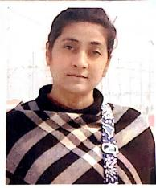  Date of Birth: 10.07.1973  Teachers Code: AYKS00494  Reg No: DBCP/A/6883  Edu. Qualification: B.A.M.S., M.D., Ph.D. (Scholar) Kriya Sharira  Designation:Principal (Ayurveda)  Date of Joining: 02/09/2008  Experience:- 20years  Contact No: +91-9818473595, 9354925026  Email ID: sujataa.rajan@gmail.com | Name: Dr. Dr. Srikanta.Kumar Panda    Date of Birth: 06/04/1970  Teachers code – AYSS01203  Reg no - DBCP-A/5801  Edu qualification – M.D.(AY.), Ph.D. (AY.)  Designation - Professor  Date of joining - 26/07/2001  Experience – 25years  Contact no - 9871553996  Email id – drspanda79@gmail.com
Name: Dr. Gugulothu Ramesh  Date of Birth: 24.06.1988  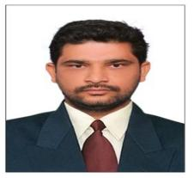  Teachers Code: AKS00535  Reg No: 891/A/2013  Edu. Qualification: M.D., Ph.D. (Scholar) Kriya Sharira  Designation: Assistant professor  Date of Joining: 13.04.2023  Experience: 6 years 6 Months 20 Days  Contact No: 9502108464/7989283869  Email ID: ramayush7@gmail.com | Name: Dr. Neha Rawat  Date of Birth: 14.09.1992    Teachers Code: AYKS00805  Reg No: DBCP/A/8876  Edu. Qualification: B.A.M.S, M.D. (Kriya Sharira)  Designation: Assistant professor  Date of Joining: 13.04.2023  Experience: 3 years 4 Months  Contact No: 9560753705  Email ID: neharawat.in@gmail.com

- Dept. of Rachana-Sharir

Name Dr. Amit kumar Sharma  Date of Birth 05/05/1974  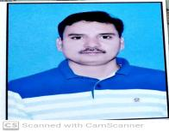  Teacher Code AYRS000623  Reg. No. DPCP/A-6959  Edu. Qualification B.A.M.S., M.D.  Designation Professor &HOD  Date of Joining 05/08/2008  Experience 20 Years  Contact No. 9873253822/9354925020  Email-id Amitdr1974@gmail.com | Name Dr. Sarang V. Ingle  Date of Birth 29/05/1983  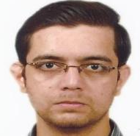  Teacher Code AYRS000624  Reg. No. I-51529-A  Edu. Qualification B.A.M.S., M.D.  Designation Associate Professor  Date of Joining 31/05/2016  Experience 13 Years  Contact No. 9970194682/9354925049  Email-id Sarang2905@gmail.com
3.
Name Dr. MILIND DESHMUKH
Date of Birth 13/02/1987
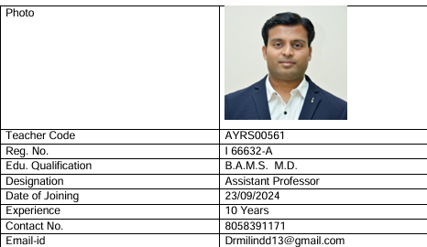
- Department of Sanskrit , Samhita Evam Siddhant

Name DR NISHI ARORA  Date of Birth 15.08.1973  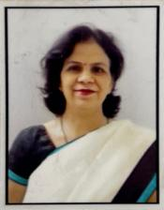  Teacher Code AYSS01202  Reg. No. 8185DBCP  Edu.Qualification BAMS, MD,Ph.D.(Samhita)  Designation Professor & HOD  Date of Joining 19.03.2000  Experience Over 23 years  Contact No. 9871050255,8076015386  Email id nishiarora_doc@yahoo.co.in | Name DR SANGEETA MISHRADate of Birth  DOB 23/05/1984  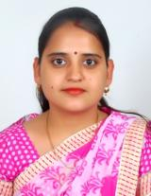  Teacher Code AYSS00912  Reg. No. 49647  Edu.Qualification BAMS, MD (Samhita), Ph.D.(Samhita), MA (Sanskrit)  Designation Associate Professor  Date of Joining 08/04/2016  Experience 10 years 2 month 16days  Contact No. 9354925052  Email id sangeetayash.mishra@gmail.com
Name: Dr. KOUSIK DAS MAHAPATRA  Date of Birth 30.12.1976  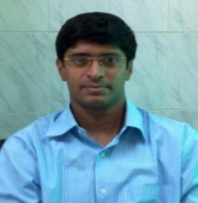  Teacher Code AYSS01199  Reg. No. 11397  Edu. Qualification BAMS, MD, PhD, MA Sanskrit  Designation Assistant professor  Date of Joining 16.9.2010  Experience 17 years  Contact No. 9582464064  Email-id drkdmahapatra@gmail.com | Dr. Mukta Sachdeva  DOB: 12/08/1972  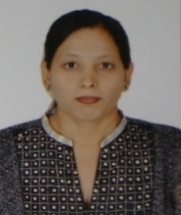  Teachers code:  Edu: MA (Sanskrit)  Designation: Lecturer  Moulika Siddhanta  Date of joining:27-1-2003  Exp:21yrs  Contact no:9013320845  Emaild-muktasachdeva72@gmail.com

- Department of Rog Nidan

Name Vaidya (Dr.) Neelam Gupta  Date of Birth 13.05.1981  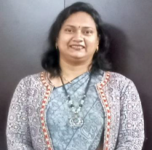  Teacher Code AYRN00482  Reg. No. BCP(UP) 50250/ central R. 105619/ 15181  Edu. Qualification BAMS, CRAV, MD, Diploma in Yoga  Designation Head of Department & Associate Professor  Date of Joining 31.03.2016  Experience 12 yrs  Contact No. 9354925051  Email-id neelamsri08@gmail.com | Name Dr. Nimisha Mishra  Date of Birth 20/12/1982  Photo  Teacher Code AYRN00657  Reg. No. 54100  Edu. Qualification BAMS, MD, PhD (Rog Nidan evum Vikriti Vigyan)  Designation Assistant Professor  Date of Joining 13/04/2023  Experience 9 years  Contact No. 8368428783  Email-id nimishamishra22@gov.in

- Department of Swasthavritta and Yoga

Name: Dr. Shilpa Shankarrao Walkikar  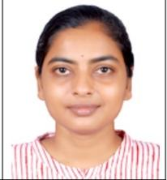  Date of Birth: 12/08/1985  Photo: enclosed as an attachment  Teacher Code: AYSV00445  Reg. No.: I- 56707-A  Edu Qualification: BAMS, MD, PhD,NDDY  Designation: Associate Professor and HOD  Date of Joining:28/08/2017  Experience: 14 years total  Contact no.: 9354925053  Email ID: shilpawalkikar.22@delhi.gov.in | Name Dr. Ankita rai    Date of Birth 07-12-1994  Teacher Code Applied  Reg. No. DBCP/A/9023  Edu. Qualification Bams,Md(Ayu),PhD(Sch)  Designation Assistant Professor  Date of Joining 13/04/2023  Experience 3 Years  Contact No. 7701841478  Email-id Drankita712@gmail.com

- Dept of Davyaguna vigyan

Dr. Rajesh Sharma  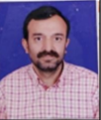  - D (Ayu).  professor  Experience-23 Years  DOB 26/11/1970 | Name Dr. Shalini Varshney (Associate Professor)  Date of Birth 01.03.1976    Teacher Code AYDG01002  Reg. No. 59009  Edu. Qualification B.A.M.S., MD (AYU), CRAV  Designation Associate Professor  Date of Joining 13.04.2016  Experience 16 Years  Contact No. 9354925050, 9897536348  Email-id shalinidr.v7@gmail.com, shalinivarshney.22@delhi.gov.in
Name Dr. Banshidhar Behera  Date of Birth 16.06.1974  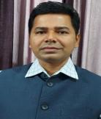  Teacher Code AYDG00979  Reg. No. 4865, Orissa State Council of Ayurvedic Medicine  Edu. Qualification M.D., Ph.D, PGDCR  Designation Associate Professor  Date of Joining 31.03.2016  Experience 16.5 years  Contact No. 9414458895  Email-id drbanshi@rediffmail.com | Name Dr. Monika Tyagi  Date of Birth 20.11.1980    Teacher Code AYDG01154  Reg. No. 49216, Board of ayurvedic and unani tibbi systems of Medicine, UP  Edu. Qualification BAMS, MD, PhD  Designation Assistant professor  Date of Joining 17.09.2010  Experience 15 years 7 months  Contact No. 9354925054  Email-id dr.monika0@gmail.com

- Dept of Ras-shastra Bhaishajyakalpana

Name Dr. BASAVARAJ S. HIREMATH
Date of Birth 05/04/1973
Photo 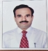
Teacher Code AYRB01186
Registration No. DBCP/A/6961
Edu Qualification MD. Ph.D
Designation Associate Professor
Date of Joining 24/11/2008
Experience PG - 2 Years, UG- 23 Years
Contact No 9354925022
Email ID Manikya_2004@rediffmail.com

- Dept of Agadtantra evam Vidhivaidyaka

Name Dr Kiran R Nimbalkar  Date of Birth 07/12/1974  Photo 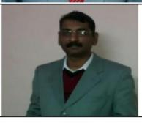  Teacher Code AYAT00325  Reg. No. DBCP/A/6958  Edu. Qualification B.A.M.S. M.D.  Designation Professor  Date of Joining 05/02/2009  Experience 18 years  Contact No. 9354925021  Email-id raynim2012@gmail.com | Name Dr. Kishor Shivaji Chaudhari  Date of Birth 01/06/1985  Photo 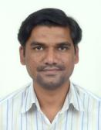  Teacher Code AYAT00126  Reg. No. GBI-24333  Edu. Qualification B.A.M.S. M.D.  Designation Assistant professor  Date of Joining 01/12/2023  Experience 11 years 05 months  Contact No. 9408681047  Email-id kishorayurved@gmail.com

- Dept of Strirog Prasyti tantra- Nil

- Dept of Kaumarabhritya- Bal Roga

Name Dr. Bhagwan Sahaya Sharma
Date of Birth 19-09-1969
Photo
Teacher Code AYKB00610
Reg. No. DBCP7080
Edu. Qualification MD (Kaumarbhritya), PhD (Ayu)
Designation Professor
Date of Joining 11-04-2001
Experience 25 Years
Contact No. 9868092246, 93549250367
Email-id vaidyabhagwan@gmail.com
Name Dr. Mukesh Kumar Meena  Date of Birth 07-05-1989  Photo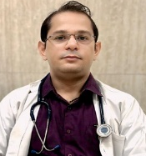  Teacher Code AYKB01218  Reg. No. 25830  Edu. Qualification MD (Kaumarbhritya)  Designation Assistant Professor  Date of Joining 07-11-2023  Experience 07 Years  Contact No. 9220037123  Email-id-drmukeshmeenabhu@gmail.com | Details of Faculties Assistant Professor  Name Dr Sonam  Date of Birth 22.09.1991  Photo  Teacher CodE AYKB01166  Reg. No. DBCP/A/8583  Edu. Qualification BAMS, MD (Ayu.), PhD.(Sch.)  Designation Assistant Professor  Date of Joining 16.02.2024  Experience Fresh  Contact No. 9220037140  Email-id sonamayutibbia@gmail.com

- Department of Panchakarma

Name Dr. Manoj k Shamkuwar
Date of Birth 01.08.1973
Photo 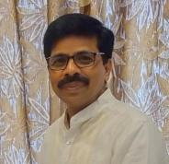
Teacher Code AYUPK00571
Reg. No. DBCP/A/6881
Edu. Qualification MD (Panchakarma), PhD, PhD-2 (Sch)
Designation Professor and Medical Superintendent
Date of Joining 17.09.2008
Experience 24 Years
Contact No. 9354925019
Email-id manoj_1873@yahoo.co.in

Name Dr. Nitin Jindal  Date of Birth 20/06/1978  Photo 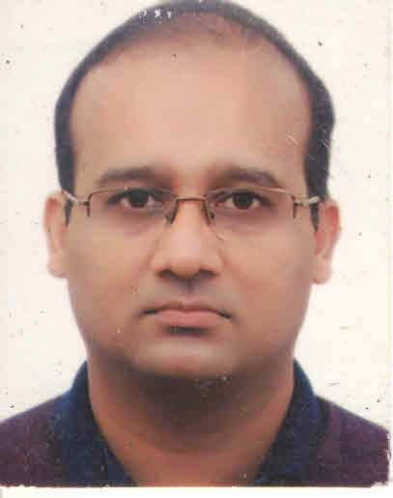  Teacher Code AYPK0668  Reg. No. DBCP/A/6960  Edu. Qualification MD (Panchakarma)  Designation Associate Professor  Date of Joining 16-02-2016  Experience 15 years 10 months  Contact No. 9811765501  Email-id nitjin2005@gmail.com | Name Dr.Shruti Balabhim Joshi  Date of Birth 13/01/1991  Photo 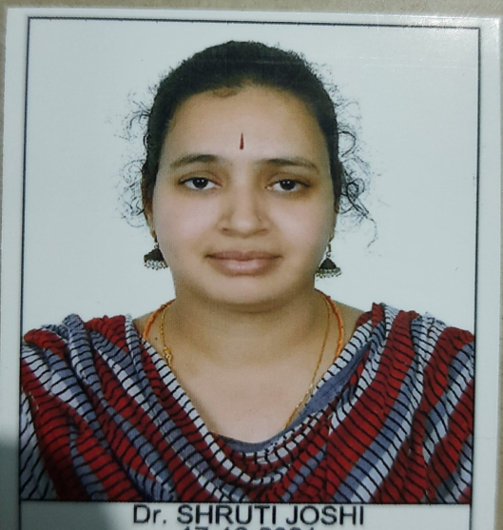  Teacher Code AYPK01199  Reg. No. 32527A  Edu. Qualification BAMS, MD , MA(YOGASHASTRA)  Designation Assistant professor  Date of Joining 25/09/2023  Experience Teaching- 1 year 9 months till date,  Medical officer 10months,  SRF - CCRAS POST COVID PROJECT-6 MONTHS  Contact No. 8277610531  Email-id shrutijoshi1391@gmail.com

- Dept of Kaychikitsa

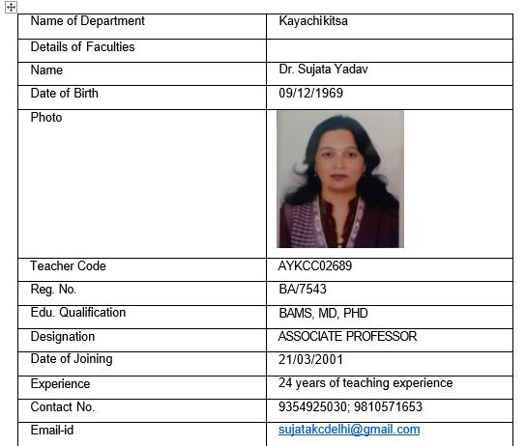 | 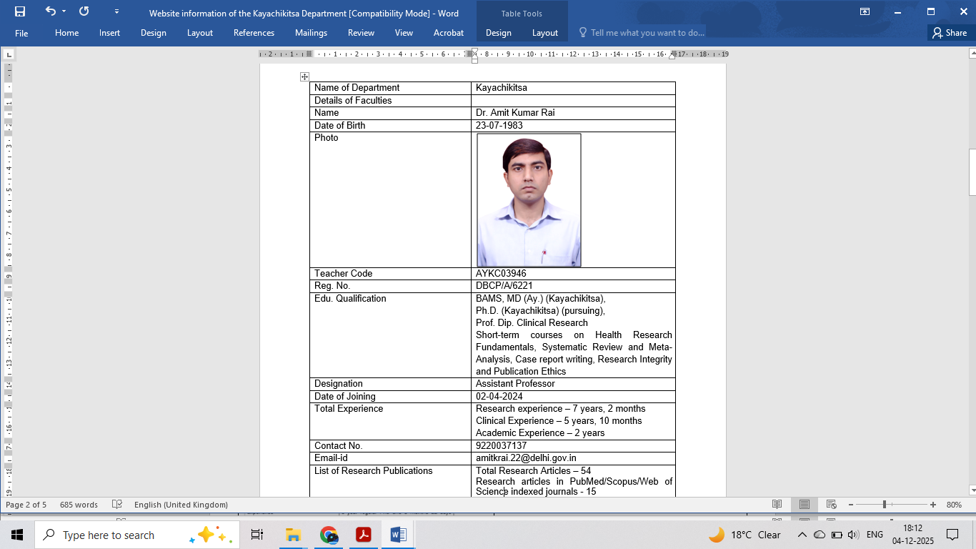
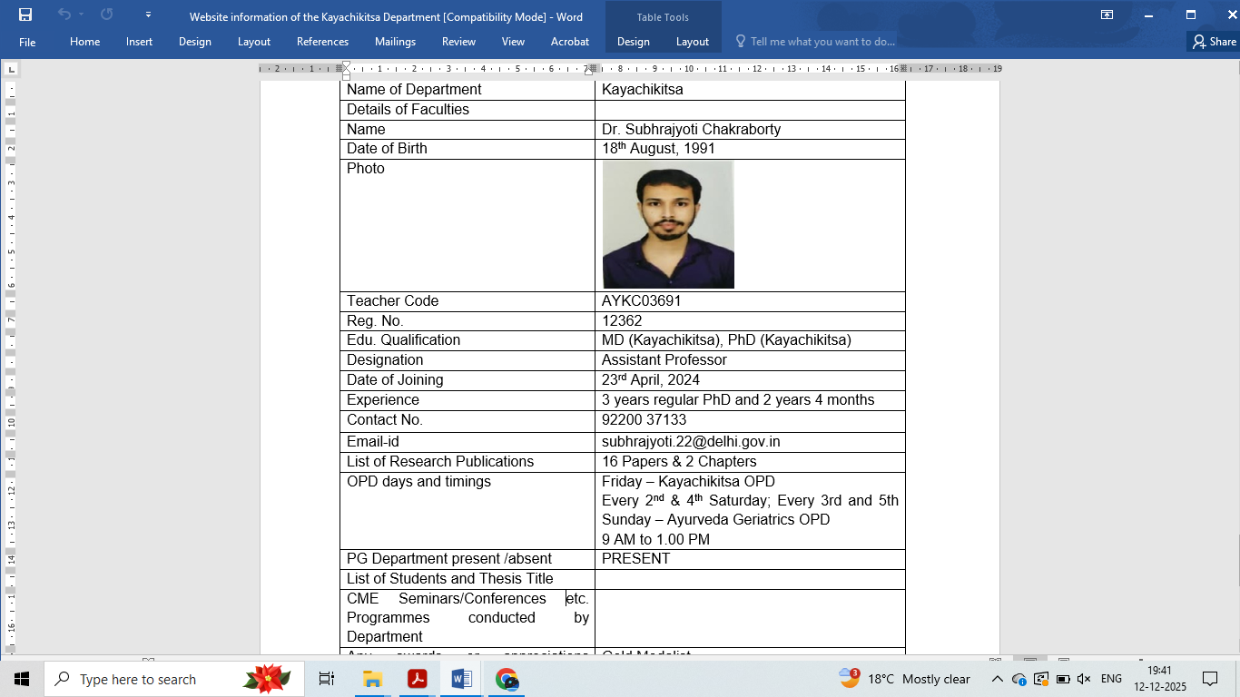
  Name | DR. UMESH PATIL
  Date of Birth | 07/04/1984
  Photo | 
  Teacher Code | AYKC00177
  Reg. No. | 50303
  Edu. Qualification | BAMS, MD (AYU), PhD(KAYACHIKITSA)
  Designation | ASSISTANT PROFESSOR
  Date of Joining | 02/04/2024
  Total Experience | 08 YEARS 10 MONTHS
  Contact No. | 9220037120
  Email-id | umeshpatil.22@delhi.gov.in
  Name | DR. RASHMI TOKAS RANA
  Date of Birth | 08/08/1989
  Photo | 
  Teacher Code | AYKC04114
  Reg. No. | 60796
  Edu. Qualification | BAMS, MD (AYU)  PhD (KAYACHIKITSA) - pursuing
  Designation | ASSISTANT PROFESSOR
  Date of Joining | 30/04/2024
  Experience | 1 YEAR 07 MONTHS
  Contact No. | 9220037135
  Email-id | rashmitokasrana.22@delhi.gov.in

- Dept of Shalyatantra

Name | Dr. Dr Praveen kumar Chaudhary | Dr.Prashant L. Rasale | Dr.Santosh R. Naik
Date of Birth | 10/03/1970 | 18/06/1982 | 01/11/1985
Photo | 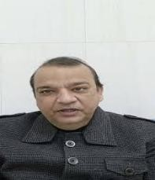 | 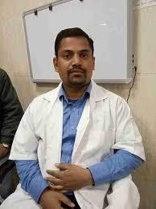 | 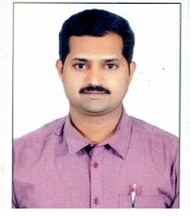
Teacher Code | AYUST01332 | AYUST01561 | AYST01329
Registration No. | DBCP/A/4075 | DBCP/A/9164 | 26030
Edu Qualification | MS(Ayu) | MS,PHD (SHALYA) | BAMSMS
Designation | Professor | Associate Professor | Asistant Professor
Date of Joining | 29/03/2001 | 11-4-2016 | 19/11/2024
Experience | 26yrs | 16 yrs | 11yrs
Contact No | 9968686823 | 9354925048 | 922037136
Email ID | Praveensurgeon9@gmail.com | prashantrasale.22delhi.gov.in | ayurveda0111@gmail.com

- Dept of Shalakyatantra

Name Dr.Rajesh kumar Chhoker
Date of Birth 30/07/1967
Photo

Teacher Code
Reg. No. DBCP/BA/7292
Edu. Qualification MS(Ayu)
Designation Associate Professor
Date of Joining 2001
Experience 23yrs
Contact No. 9868266668
Email-id -
Name Dr Haramohan Moharana  Date of Birth 03.02.1975  Photo 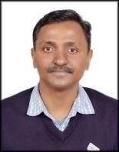  Teacher Code AYSK00501  Reg. No. DBCP/A/6892  Edu. Qualification M.S.(Ay.), PhD (Ay.)  Designation Associate Prof.  Date of Joining 07.10.2008  Experience 20 years  Contact No. 9711158121  Email-id hariom3275@gmail.com | Name DR. POONAM DHRUV  Date of Birth 10/04/1990  Photo   Teacher Code AYSK01180  Reg. No. DBCP/A/8432  Edu. Qualification BAMS, MS(SHALAKYA TANTA)  Designation ASSISTANT PROFESSOR  Date of Joining 13/04/2023  Experience 01 year  Contact No. 9540904293  Email-id virgo2714@gmail.com

