A & U Tibbia College and Hospital

Govt of NCT of Delhi

KarolBah, New Delhi-110005

**List of Teaching Staff (Ayurved)**

1. **Sharir kriya Dept.**

|  |  |
| --- | --- |
| **Name:** Dr. Sujata Rajan  IMG-20240630-WA0018  **Date of Birth:** 10.07.1973  **Teachers Code:** AYKS00494  **Reg No:** DBCP/A/6883  **Edu. Qualification:** B.A.M.S., M.D., Ph.D. (Scholar) Kriya Sharira  **Designation:** Vice- principal, Academic Head (Ayurveda), Associate Professor  **Date of Joining:** 02/09/2008  **Experience:-** 19 years  **Contact No**: +91-9818473595, 9354925026  **Email ID:** sujataa.rajan@gmail.com | **Name:** Dr. Dr. Srikanta.Kumar Panda  Picture1  **Date of Birth:** 06/04/1970  Teachers code – AYSS01203  Reg no - DBCP-A/5801  Edu qualification – M.D.(AY.), Ph.D. (AY.)  Designation - Professor  Date of joining - 26/07/2001  Experience – 24 years  Contact no - 9871553996  Email id – drspanda79@gmail.com |
| **Name:** Dr. Gugulothu Ramesh  **Date of Birth:** 24.06.1988    **Teachers Code:** AKS00535  **Reg No:** 891/A/2013  **Edu. Qualification:** M.D., Ph.D. (Scholar) Kriya Sharira  **Designation:** Assistant professor  **Date of Joining:** 13.04.2023  **Experience:** 6 years 6 Months 20 Days  **Contact No**: 9502108464/7989283869  **Email ID:** [ramayush7@gmail.com](mailto:ramayush7@gmail.com) | **Name:** Dr. Neha Rawat  **Date of Birth:** 14.09.1992    **Teachers Code:** AYKS00805  **Reg No:** DBCP/A/8876  **Edu. Qualification:** B.A.M.S, M.D. (Kriya Sharira)  **Designation:** Assistant professor  **Date of Joining:** 13.04.2023  **Experience:** 3 years 4 Months  **Contact No**: 9560753705  **Email ID:** [neharawat.in@gmail.com](mailto:neharawat.in@gmail.com) |

1. **Dept. of Rachana-Sharir**

|  |  |
| --- | --- |
| Name Dr. Amit kumar Sharma  Date of Birth 05/05/1974  C:\Users\sarang ingle\Desktop\Dr Amit.jpeg  Teacher Code AYRS000623  Reg. No. DPCP/A-6959  Edu. Qualification B.A.M.S., M.D.  Designation Professor &HOD  Date of Joining 05/08/2008  Experience 20 Years  Contact No. 9873253822/9354925020  Email-id Amitdr1974@gmail.com | Name Dr. Sarang V. Ingle  Date of Birth 29/05/1983  C:\Users\sarang ingle\pd scan\Sarang\Sarang colour photo.jpg  Teacher Code AYRS000624  Reg. No. I-51529-A  Edu. Qualification B.A.M.S., M.D.  Designation Associate Professor  Date of Joining 31/05/2016  Experience 13 Years  Contact No. 9970194682/9354925049  Email-id Sarang2905@gmail.com |

1. **Department of Sanskrit , Samhita Evam Siddhant**

|  |  |
| --- | --- |
| **Name DR NISHI ARORA**  Date of Birth 15.08.1973  Document 64_1.jpeg  Teacher Code AYSS01202  Reg. No. 8185DBCP  Edu.Qualification BAMS, MD,Ph.D.(Samhita)  Designation Professor & HOD  Date of Joining 19.03.2000  Experience Over 23 years  Contact No. 9871050255,8076015386  Email id nishiarora\_doc@yahoo.co.in | Name DR SANGEETA MISHRADate of Birth  DOB 23/05/1984  C:\Users\HP\Desktop\DSC_7593.JPG  Teacher Code AYSS00912  Reg. No. 49647  Edu.Qualification BAMS, MD (Samhita), Ph.D.(Samhita), MA (Sanskrit)  Designation Associate Professor  Date of Joining 08/04/2016  Experience 10 years 2 month 16days  Contact No. 9354925052  Email id sangeetayash.mishra@gmail.com |
| **Name: Dr. KOUSIK DAS MAHAPATRA**  Date of Birth 30.12.1976  Picture1  Teacher Code AYSS01199  Reg. No. 11397  Edu. Qualification BAMS, MD, PhD, MA Sanskrit  Designation Assistant professor  Date of Joining 16.9.2010  Experience 17 years  Contact No. 9582464064  Email-id [drkdmahapatra@gmail.com](mailto:drkdmahapatra@gmail.com" \t "https://mail.google.com/mail/u/0/" \l "inbox/_blank) | Dr. Mukta Sachdeva  DOB: 12/08/1972  Picture2  Teachers code:  Edu: MA (Sanskrit)  Designation: Lecturer  Moulika Siddhanta  Date of joining:27-1-2003  Exp:21yrs  Contact no:9013320845  Emaild-muktasachdeva72@gmail.com |

1. **Department of Rog Nidan**

|  |  |
| --- | --- |
| Name Vaidya (Dr.) Neelam Gupta  Date of Birth 13.05.1981    Teacher Code AYRN00482  Reg. No. BCP(UP) 50250/ central R. 105619/ 15181  Edu. Qualification BAMS, CRAV, MD, Diploma in Yoga  Designation Head of Department & Associate Professor  Date of Joining 31.03.2016  Experience 12 yrs  Contact No. 9354925051  Email-id neelamsri08@gmail.com | Name Dr. Nimisha Mishra  Date of Birth 20/12/1982  Photo  Teacher Code AYRN00657  Reg. No. 54100  Edu. Qualification BAMS, MD, PhD (Rog Nidan evum Vikriti Vigyan)  Designation Assistant Professor  Date of Joining 13/04/2023  Experience 9 years  Contact No. 8368428783  Email-id nimishamishra22@gov.in |

1. **Department of Swasthavritta and Yoga**

|  |  |
| --- | --- |
| **Name: Dr. Shilpa Shankarrao Walkikar**    **Date of Birth: 12/08/1985**  **Photo: enclosed as an attachment**  **Teacher Code: AYSV00445**  **Reg. No.: I- 56707-A**  **Edu Qualification: BAMS, MD, PhD(Sch)**  **Designation: Associate Professor**  **Date of Joining:28/08/2017**  **Experience: 11 years total**  **Contact no.: 9354925053**  **Email ID: [shilpawalkikar.22@delhi.gov.in](mailto:shilpawalkikar.22@delhi.gov.in" \t "https://mail.google.com/mail/u/0/" \l "inbox/_blank)** | **Name Dr. Ankita rai**  Copy of 9776F51B-FC8C-41A8-AEED-64611E7AE104  Date of Birth 07-12-1994  Teacher Code Applied  Reg. No. DBCP/A/9023  Edu. Qualification Bams,Md(Ayu),PhD(Sch)  Designation Assistant Professor  Date of Joining 13/04/2023  Experience 3 Years  Contact No. 7701841478  Email-id Drankita712@gmail.com |

1. **Dept of Davyaguna vigyan**

|  |  |
| --- | --- |
| Dr. Rajesh Sharma     1. D (Ayu).   professor  Experience-23 Years  DOB 26/11/1970 | Name Dr. Shalini Varshney (Associate Professor)  Date of Birth 01.03.1976    Teacher Code AYDG01002  Reg. No. 59009  Edu. Qualification B.A.M.S., MD (AYU), CRAV  Designation Associate Professor  Date of Joining 13.04.2016  Experience 16 Years  Contact No. 9354925050, 9897536348  Email-id shalinidr.v7@gmail.com, [shalinivarshney.22@delhi.gov.in](mailto:shalinivarshney.22@delhi.gov.in) |
| Name Dr. Banshidhar Behera  Date of Birth 16.06.1974    Teacher Code AYDG00979  Reg. No. 4865, Orissa State Council of Ayurvedic Medicine  Edu. Qualification M.D., Ph.D, PGDCR  Designation Associate Professor  Date of Joining 31.03.2016  Experience 16.5 years  Contact No. 9414458895  Email-id drbanshi@rediffmail.com | Name Dr. Monika Tyagi  Date of Birth 20.11.1980    Teacher Code AYDG01154  Reg. No. 49216, Board of ayurvedic and unani tibbi systems of Medicine, UP  Edu. Qualification BAMS, MD, PhD  Designation Assistant professor  Date of Joining 17.09.2010  Experience 15 years 7 months  Contact No. 9354925054  Email-id dr.monika0@gmail.com |

1. **Dept of Ras-shastra Bhaishajyakalpana**

|  |
| --- |
| Name Dr. BASAVARAJ S. HIREMATH  Date of Birth 05/04/1973  Photo  Teacher Code AYRB01186  Registration No. DBCP/A/6961  Edu Qualification MD. Ph.D  Designation Associate Professor  Date of Joining 24/11/2008  Experience PG - 2 Years, UG- 23 Years  Contact No 9354925022  Email ID Manikya\_2004@rediffmail.com |

1. **Dept of Agadtantra evam Vidhivaidyaka**

|  |  |
| --- | --- |
| Name Dr Kiran R Nimbalkar  Date of Birth 07/12/1974  Photo 1719746331286  Teacher Code AYAT00325  Reg. No. DBCP/A/6958  Edu. Qualification B.A.M.S. M.D.  Designation Professor  Date of Joining 05/02/2009  Experience 18 years  Contact No. 9354925021  Email-id raynim2012@gmail.com | Name Dr. Kishor Shivaji Chaudhari  Date of Birth 01/06/1985  Photo E:\Biodata\Passportsize photograph\Copy of 00010.jpg  Teacher Code AYAT00126  Reg. No. GBI-24333  Edu. Qualification B.A.M.S. M.D.  Designation Assistant professor  Date of Joining 01/12/2023  Experience 11 years 05 months  Contact No. 9408681047  Email-id kishorayurved@gmail.com |

1. **Dept of Strirog Prasyti tantra- Nil**
2. **Dept of Kaumarabhritya- Bal Roga**

|  |  |
| --- | --- |
| **Name  Dr. Bhagwan Sahaya Sharma**  **Date of Birth  19-09-1969**  **Photo**C:\Users\dell\Desktop\IMG-20240627-WA0004.jpg  **Teacher Code  AYKB00610**  **Reg. No.  DBCP7080**  **Edu. Qualification  MD (Kaumarbhritya), PhD (Ayu)**  **Designation  Professor**  **Date of Joining  11-04-2001**  **Experience  25 Years**  **Contact No.  9868092246, 93549250367**  **Email-id  vaidyabhagwan@gmail.com** | |
| **Name Dr. Mukesh Kumar Meena**  **Date of Birth  07-05-1989**  **Photo**C:\Users\dell\Desktop\IMG-20240628-WA0003.jpg  **Teacher Code  TCRA000051424**  **Reg. No.  25830**  **Edu. Qualification  MD (Kaumarbhritya)**  **Designation  Assistant Professor**  **Date of Joining  07-11-2023**  **Experience  07 Years**  **Contact No.  8318540284,**  **Email-id-drmukeshmeenabhu@gmail.com** | **Details of Faculties Assistant Professor**  **Name Dr Sonam**  **Date of Birth 22.09.1991**  **Photo**C:\Users\Dell\Desktop\Image.jpg  **Teacher Code Applied**  **Reg. No. DBCP/A/8583**  **Edu. Qualification BAMS, MD (Ayu.), PhD.(Sch.)**  **Designation Assistant Professor**  **Date of Joining 16.02.2024**  **Experience Fresh**  **Contact No. 8285842084**  **Email-id sonamayutibbia@gmail.com** |

1. **Department of Panchakarma**

|  |  |
| --- | --- |
| **Name Dr. Manoj k Shamkuwar**  **Date of Birth 01.08.1973**  **Photo**  **Teacher Code AYUPK00571**  **Reg. No. DBCP/A/6881**  **Edu. Qualification MD (Panchakarma), PhD, PhD-2 (Sch)**  **Designation Professor and Medical Superintendent**  **Date of Joining 17.09.2008**  **Experience 24 Years**  **Contact No. 9354925019**  **Email-id [manoj\_1873@yahoo.co.in](mailto:manoj_1873@yahoo.co.in)** | |
| **Name Dr. Nitin Jindal**  **Date of Birth 20/06/1978**  **Photo** C:\Users\Administrator\Desktop\nitin new photo scanned.jpg  **Teacher Code AYPK0668**  **Reg. No. DBCP/A/6960**  **Edu. Qualification MD (Panchakarma)**  **Designation Associate Professor**  **Date of Joining 16-02-2016**  **Experience 15 years 10 months**  **Contact No. 9811765501**  **Email-id nitjin2005@gmail.com** | **Name Dr.Shruti Balabhim Joshi**  **Date of Birth 13/01/1991**  **Photo**  **Teacher Code AYPK01199**  **Reg. No. 32527A**  **Edu. Qualification BAMS, MD , MA(YOGASHASTRA)**  **Designation Assistant professor**  **Date of Joining 25/09/2023**  **Experience Teaching- 1 year 9 months till date,**  **Medical officer 10months,**  **SRF - CCRAS POST COVID PROJECT-6 MONTHS**  **Contact No. 8277610531**  **Email-id shrutijoshi1391@gmail.com** |

1. **Dept of Kaychikitsa**

|  |  |
| --- | --- |
|  |  |
|  |  |
|  |  |

1. **Dept of Shalyatantra**

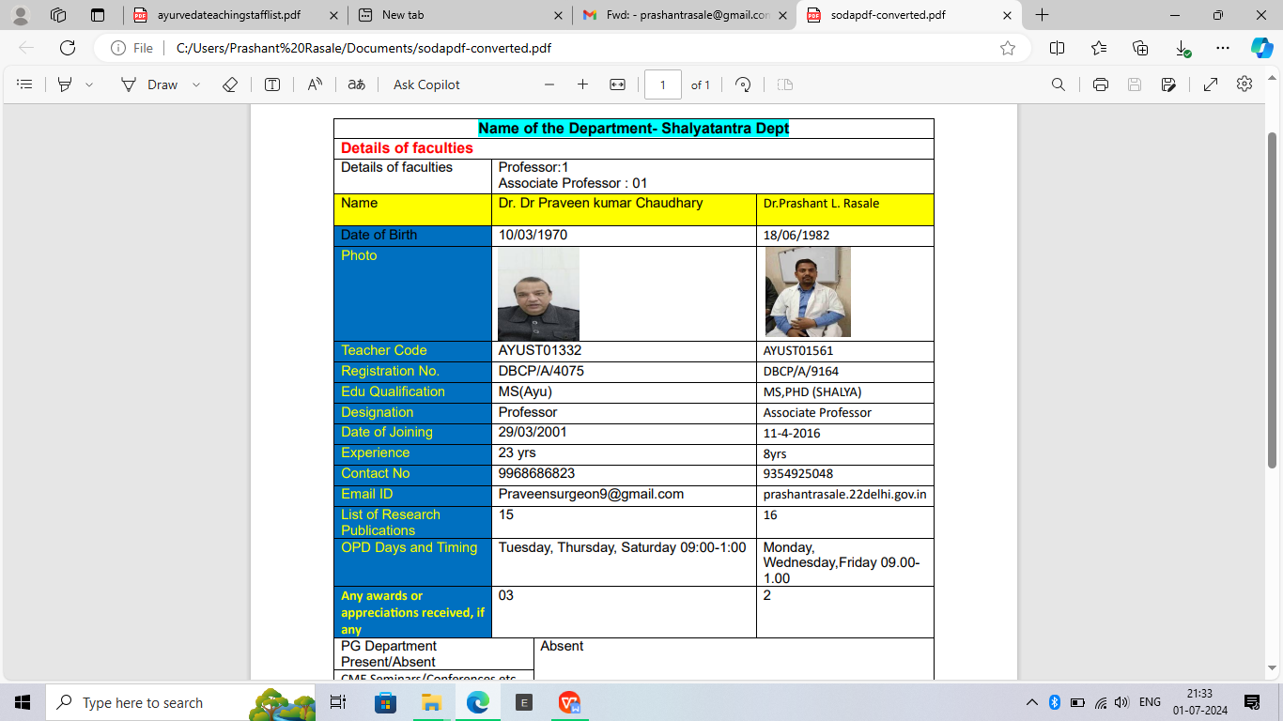

1. **Dept of Shalakyatantra**

|  |  |
| --- | --- |
| **Name Dr.Rajesh kumar Chhoker**  **Date of Birth 30/07/1967**  **Photo**  **Teacher Code**  **Reg. No. DBCP/BA/7292**  **Edu. Qualification MS(Ayu)**  **Designation Associate Professor**  **Date of Joining 2001**  **Experience 23yrs**  **Contact No. 9868266668**  **Email-id -** | |
| **Name Dr Haramohan Moharana**  **Date of Birth 03.02.1975**  **Photo** D:\Haramohan\Passport Size photo\Haramohan.JPG  **Teacher Code AYSK00501**  **Reg. No. DBCP/A/6892**  **Edu. Qualification M.S.(Ay.), PhD (Ay.)**  **Designation Associate Prof.**  **Date of Joining 07.10.2008**  **Experience 20 years**  **Contact No. 9711158121**  **Email-id hariom3275@gmail.com** | **Name DR. POONAM DHRUV**  **Date of Birth 10/04/1990**  **Photo** 1719653177030  **Teacher Code AYSK01180**  **Reg. No. DBCP/A/8432**  **Edu. Qualification BAMS, MS(SHALAKYA TANTA)**  **Designation ASSISTANT PROFESSOR**  **Date of Joining 13/04/2023**  **Experience 01 year**  **Contact No. 9540904293**  **Email-id virgo2714@gmail.com** |